User Social Impact Survey

Follow-Up In-Person Survey

This follow-up survey should be conducted with the same users who took part in the baseline in-person User Social Impact Survey when 6 months (or 1 year) have passed since the users first bought or received the clean and/or efficient cookstove/fuel. In this survey, the focus is on the respondents’ lives now that they have been using the clean and/or efficient cookstove/fuel for 6 months (or 1 year).

- The light blue modules and questions are optional, as they may not be applicable to some organizations’ operations.

- Text in italics represents directions for the data collector and does not need to be read aloud to the respondent.

- Text [bracketed with italicized bold black font] indicates text that the data collector should customize based on a response the respondent provided earlier in the survey (e.g., the type of cookstove she purchased).

- Text [bracketed with italicized orange font] indicates text that you should customize (e.g., the types of cookstoves, response options that are most appropriate for the local context, etc.) before beginning the data collection.

- Text in italicized green font indicates to the data collector that these questions involve skip patterns.

- The star symbol (*) denotes questions for which the data collector should list the answer options out loud and have the respondent choose the most applicable answer.

- The triangle symbol (Δ) denotes questions for which the data collector should let the respondent answer the question in his/her own words. The data collector should then select the option that best matches the response. The list of options should NOT be read out loud.

Before you begin to administer the survey:

- Enter User IDs for each respondent. These IDs should be the same as those assigned at the baseline.

- Replace every reference to “6 months (1 year)” in the survey with the time period (either 6 months or 1 year) that your data collection team decided would be suitable prior to conducting the baseline survey; this text will appear [bracketed with italicized orange font].

- For Module C, designate the same 4-6 context-specific cooking tasks that your organization used at baseline. These 4-6 tasks should replace the examples (“making tea,” “making rice,” etc.), which currently appear in text [bracketed with italicized orange font].

- For Modules C & E, enter in the same designations for “Season 1” and “Season 2” (and their lengths) as those used at baseline. Write the names of the seasons and their lengths in the box below, as a point of reference. You should also edit the survey to replace all the text [bracketed with italicized orange font] with the same terms as those used in the baseline survey, making sure not to skip references to “Season 1” and “Season 2,” particularly in the tables.

 | Name of season: (e.g., rainy season) | Length of season:
Season 1: |  | ______ months
Season 2: |  | ______ months

User ID (use same ID as at baseline): ________________________

- Background Information

Product Information

Read the following directions aloud to the respondent:
Please answer the following questions related to your personal information:

Q # | Question to be read aloud to respondent | Answer to be filled in/circled by enumerator
A1. | What was the type/name of the clean cooking product you bought or received from [the organization]? *  (List options and let respondent choose) | - [name of product 1]  - [name of product 2]  - [name of product 3]
A2. | How long ago did you buy or receive the [clean cooking product/device]?  (If the respondent provides a date of purchase, please calculate how many months ago this was, based on today’s date) | ______ months ago

- Household Economic Stability

B1. | How many household members (boys and girls) are in between the ages of 0 and 5?  And how many between the ages of 6 and 17?  (Write down number for each category) | Ages 0-5  Boys: ______  Girls: ______ | Ages 6-17  Boys: ______  Girls: ______
B2. | How many boys and girls in the household attend school?  (Skip if there are no children in the household)  (Write down number for each category) | Boys: ______  Girls: ______

- Usage/Adoption and Cooking Time

Read aloud to respondent:

I would like to discuss the main cooking tasks you do (or did) in an average week BEFORE you bought or received the [clean cooking product].
In a normal week, do you cook… [cooking tasks listed “ a.”-“f.”]?

Check off the cooking tasks for which the respondent says YES.

Starting with the first cooking task that was checked off, ask question “C1a.” and write down the number of times the respondent does this cooking task in an average week during [Season 1] . Next, ask question “C1b.”as it is written (first ask about the main cooking method/device used in [Season 1] and then ask whether there are any other cooking methods/devices used for that cooking task during [Season 1]) and write in the appropriate code in the column to the right of “1.”, “2.”, and “3.”

Next, ask questions “C1c.” and “C1d.” for the main cooking method/device (again, for [Season 1]) and then ask questions “C1c.” and “C1d.” again for any other cooking methods/devices used during [Season 1]. Explain that when you ask about “the number of minutes it took to cook the [cooking task checked off],” you mean from the time the respondent lit the fire to the time the food was done cooking and removed from the fire.

Once the respondent has answered question “C1c.” for each cooking device for that cooking task, double-check that the number of times they report using each cooking device/method per week adds up to the number you wrote down in “C1a.”

For example: If the respondent said s/he makes tea twice a day (14 times per week), but s/he then reports using a pellet stove to make tea twice a day, an LPG stove to make tea twice a day, and a fixed mud stove to make tea twice a day, that adds up to tea being made 6 times per day (42 times per week). This is a common mistake, and you should prompt the respondent to clarify . The resulting answer may be that s/he always makes tea in the morning with the pellet stove (7 times per week), and s/he switches off between the LPG stove and the fixed mud stove to make tea at dinner time, so write down 3.5 times per week for the LPG stove and 3.5 times per week for the fixed mud stove.

Once all the questions for the current season have been asked (“C1a.”-“C1d.” for all devices for cooking task “a.”), ask whether there are any distinctions between performing this cooking task in [Season 1] and doing it in [Season 2] (“C2.”).

If the respondent answers YES, ask about all of the cooking methods/devices used for that cooking task during [Season 2] (questions “C3a.”-“C3d.” for that same cooking task).

If the respondent says NO, you can either copy his/her response from the [Season 1] section to the [Season 2] section (questions “C3a.”-“C3d.”) or just write “SAME” across that section for that cooking task in [Season 2].

Once you have finished both seasons for one cooking task (i.e., you have completed “C1a.”-“C3d.” for cooking task “a.”), move to the next cooking task (“b.”-“f.”) that was checked off. Ask all the questions for [Season 1] and then [Season 2] if the answer to “C2.” is YES.

NOTE: If the participant is not using the clean and/or efficient cooking device/method at least once per week or has used it less than 10 total times, you can stop the interview here.
COOKING TASKS  Over the past [6 months  (1 year)] | Check if applicable | How many times in an average week did you do [cooking task checked off] during [Season 1]? | What was the main cooking method/device you used for [cooking task checked off] during [Season 1]? Δ Do you ever use a different cooking method/ device for [the same cooking task]? If so, what?  Cooking method/device:  1- Three-stone fire  2- Fixed mud stove  3- Local improved wood stove  4- High efficiency improved wood stove  5- Traditional charcoal stove  6- Local improved charcoal stove (ceramic liner)  7- High efficiency improved charcoal stove  8- Kerosene stove  9- LPG stove  10- Biogas stove  11- Electric stove  12- Briquette stove  13- Pellet stove  97- Other (specify)  99- Not applicable |  | How many times in an average week did you do [cooking task checked off] with this [cooking method/ device] during [Season 1]? | Each time you did this task during  [Season 1], how many minutes  did it take to do [cooking task checked off] when using the [cooking method/  device]? | Are the cooking devices or the amount of time you require for this cooking task different during [Season 2]? | How many times in an average week did you do [cooking task checked off] during [Season 2]? | What was the main cooking method/device you used for [cooking task checked off] during [Season 2]? Δ  Do you ever use a different cooking method/device for [the same cooking task]?  If so, what? | How many times in an average week did you do [cooking task checked off] with this [cooking method/ device] during [Season 2]? | Each time you did this task during [Season 2], how many minutes  did it take to do [cooking task checked off] when using the [cooking method/  device]?
Cooking Task |  | C1: [SEASON 1] |  |  |  |  |  | C3: [SEASON 2]
 |  | C1a. | C1b. |  | C1c. | C1d. | C2. | C3a. | C3b. | C3c. | C3d.
EXAMPLE: Making tea | ✓ | 14 | 1. | 13. (pellet stove) | 7 (daily) | 10 min | Yes | 14 | 1. (3-stone fire) | 7 | 40 min
 |  |  | 2. | 2. (fixed mud stove) | 3.5 | 30 min |  |  | 2. (fixed mud stove) | 7 | 30 min
 |  |  | 3. | 9. (LPG) | 3.5 | 5 min |  |  | 99. (N/A)
a. [Making tea] |  |  | 1.
 |  |  | 2.
 |  |  | 3.
b. [Making rice] |  |  | 1.
 |  |  | 2.
 |  |  | 3.
c. [Cooking beans] |  |  | 1.
 |  |  | 2.
 |  |  | 3.
d. [Cooking fish] |  |  | 1.
 |  |  | 2.
 |  |  | 3.
e. [Heating water for bathing/ cleaning] |  |  | 1.
 |  |  | 2.
 |  |  | 3.
f. Other: |  |  | 1.
 |  |  | 2.
 |  |  | 3.

- Cooking: Dynamics, Drudgery, and Safety & Health
Cooking Dynamics

Read aloud to respondent:
So now that you have been using the [clean cooking product/device] along with [any other cooking method/device mentioned in Section C] for the past [6 months (1 year)]…

D1. | Who does the cooking now? Δ  (Let the respondent list and choose the option that best matches his/her response)  PROBE: Does anyone else help out?  (can select multiple) | - Woman  - Man  - Girl  - Boy  - House help  - Other (Specify:_________________)  - Don’t know
D2. | Does your husband ever help out with the cooking?  (Skip if respondent is a man) | - Never  - Sometimes  - Always  99- Not applicable
D3. | Do you do anything else while cooking?  (i.e., multi-tasking) | - Yes  - No  - Not applicable
D4. | When you think about how much time is required for cooking with the [clean cooking product/device] (in addition to the [other cooking method(s) previously mentioned]), would you say it is less, about the same, or more as the amount of time that was required before, when you were cooking only with the [cooking method(s) being used previously]? | - Less (continue to below)  - About the same (skip to question D8.)  - More (skip to question D8.)  98- Don’t know (skip to question D8.)
D5. | How are you using the time saved from cooking? Δ  (Let the respondent list and choose the option that best matches his/her response)  If the respondent lists income generation, ask questions D6. and D7. Otherwise, skip to question D8. | - Taking care of children or other members of the household  - Helping children with their studies  - Working in the field  - Cleaning house/domestic tasks  - Income-generating activities (ask questions D6. & D7.)  - Social activities  - Leisure/ resting/ recreational activities  - Saved time too small to use for any specific purpose  97- Other (Specify:_________________)  98- Don’t know
D6. | What is the income-generating activity you do?  (Ask this and the following question only if the respondent mentioned income generation in the previous question)
D7. | In an average month, approximately how much do you earn from this income-generating activity?  (If the respondent lists the amount per week, multiply by 4 to get the amount per month) | _______ / month  (local currency)
Cooking Drudgery

D8. | Read aloud to respondent:  Now I want you to think about the level of effort required for cooking- including the effort of preparing the fuel, lighting the fire, tending to the fire, and managing the food. I am going to ask you to use the pictures below to tell me about this level of effort. They represent a task that requires no effort, up to a task that requires an extreme amount of effort.  Please first point to the picture that matches the amount of effort you spent on cooking BEFORE you had the [clean cooking project/device], when you were cooking only with the old method(s).  Please think of all of the different cooking methods you used before.  Mark down answer in the box below the picture that the respondent points to (“D8a.”).  Now, please point to the picture that matches the amount of effort you spend on cooking NOW that you are using the [clean cooking product/device] along with the [other cooking method(s) previously mentioned]. Please think of all of the different cooking methods you use now.  Mark down answer in the box below the picture that the respondent points to (“D8b.”).

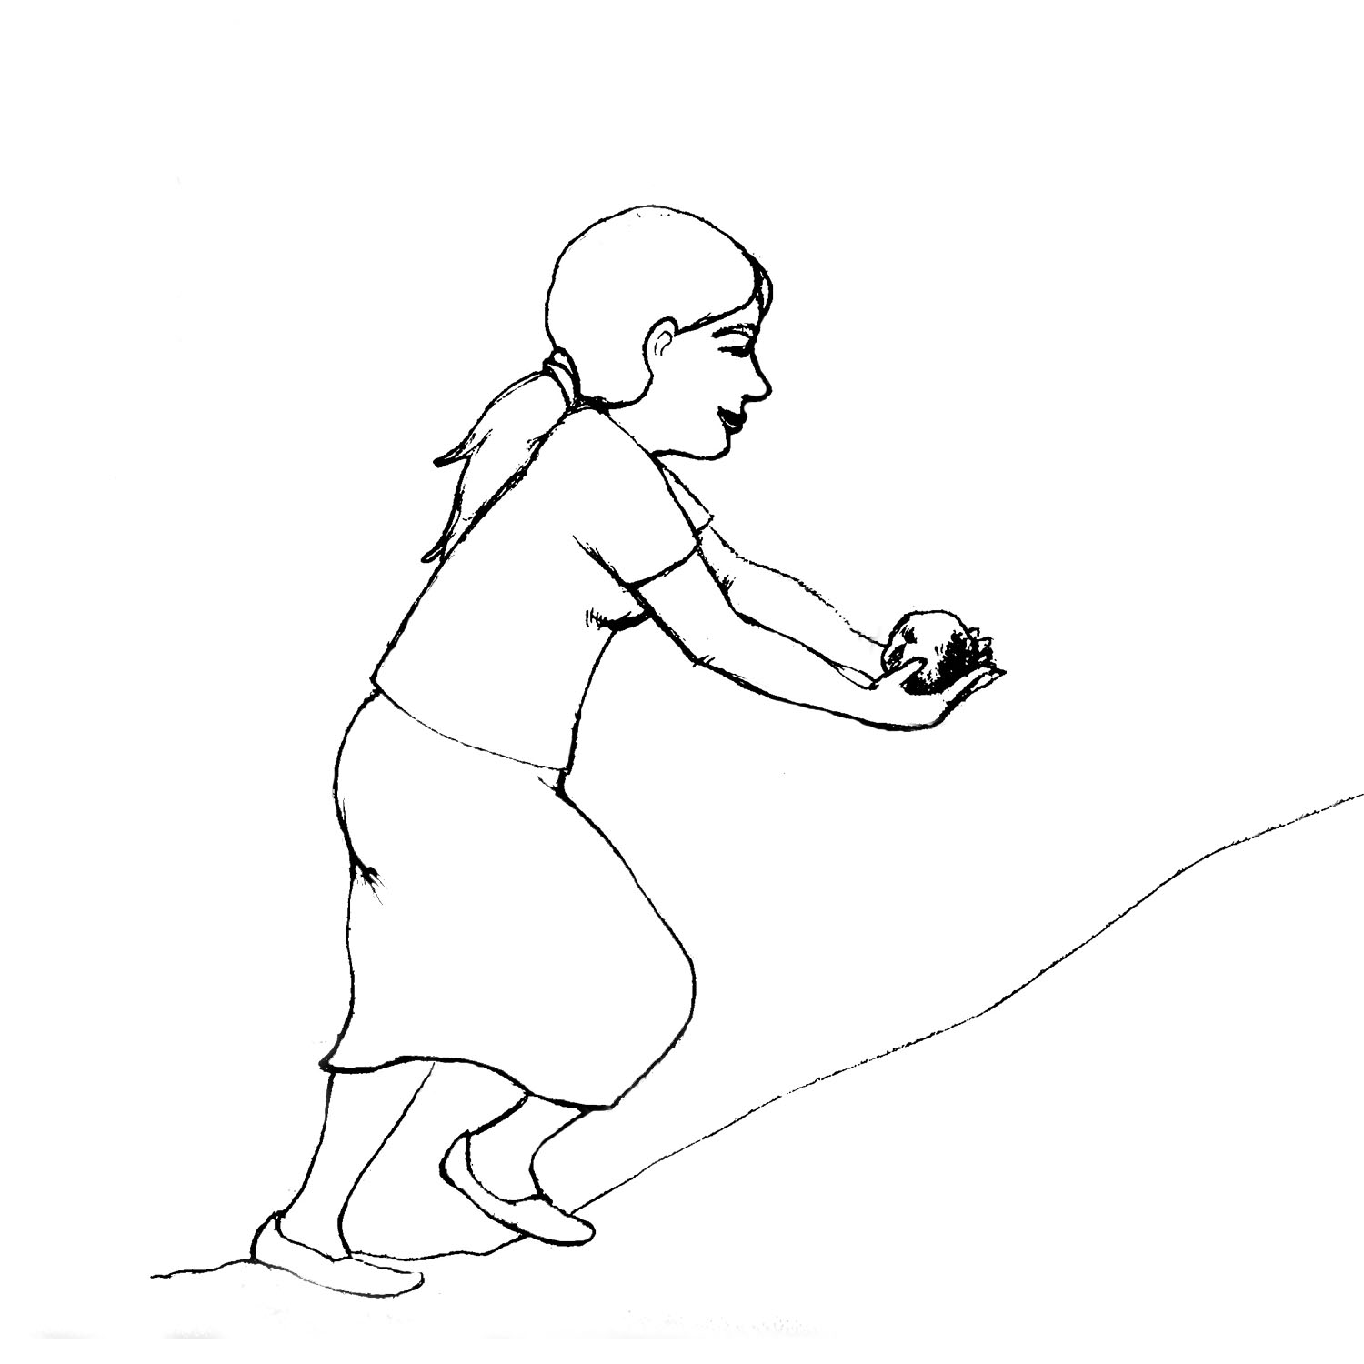
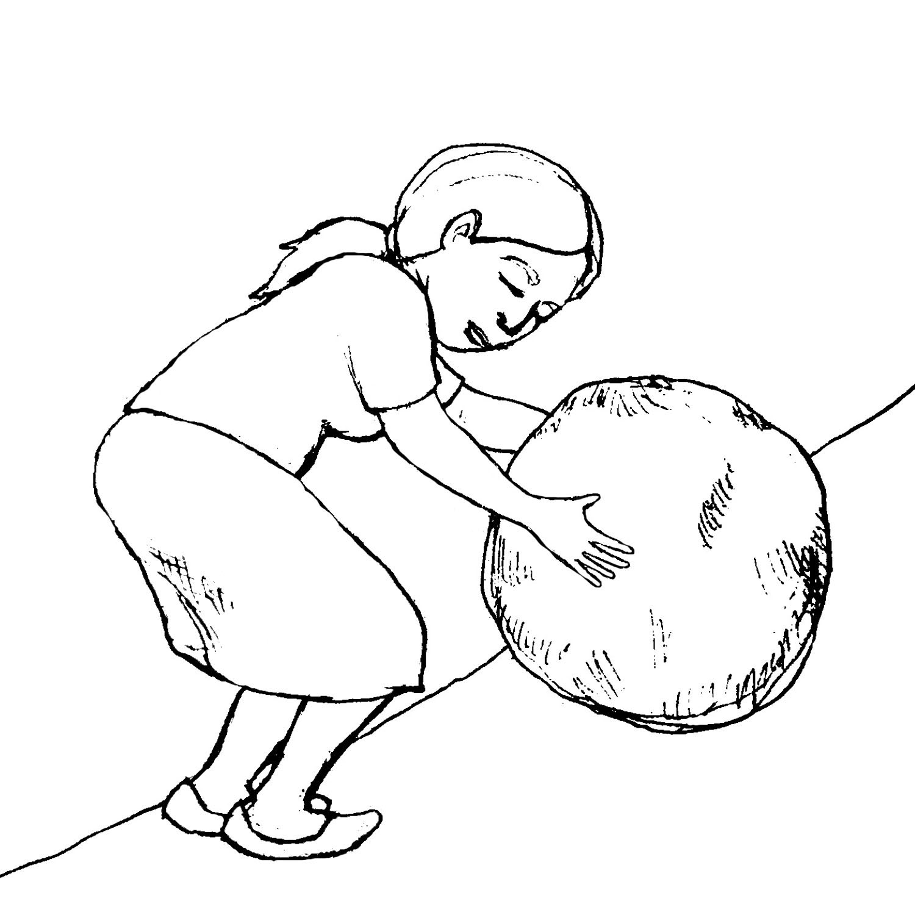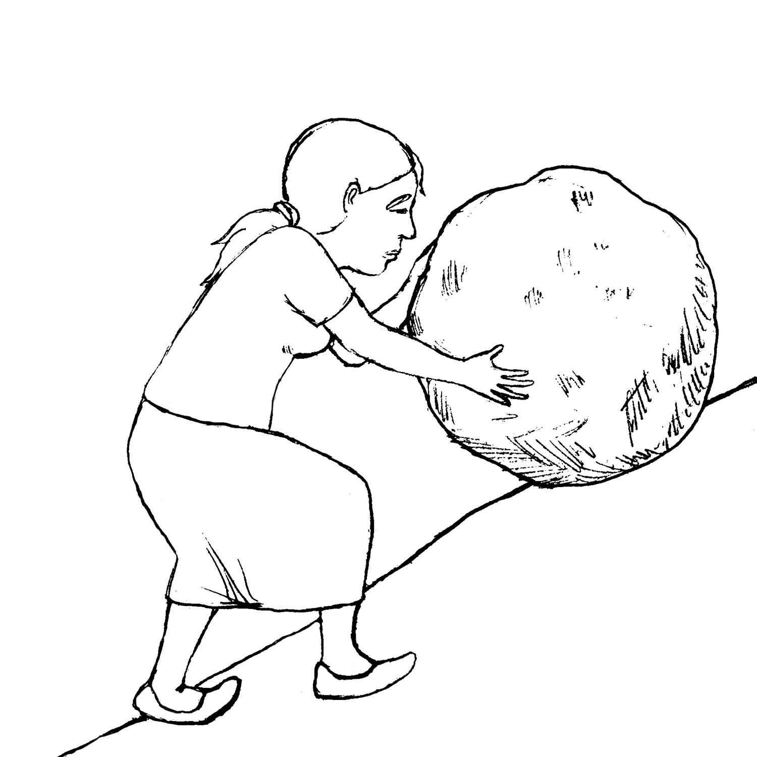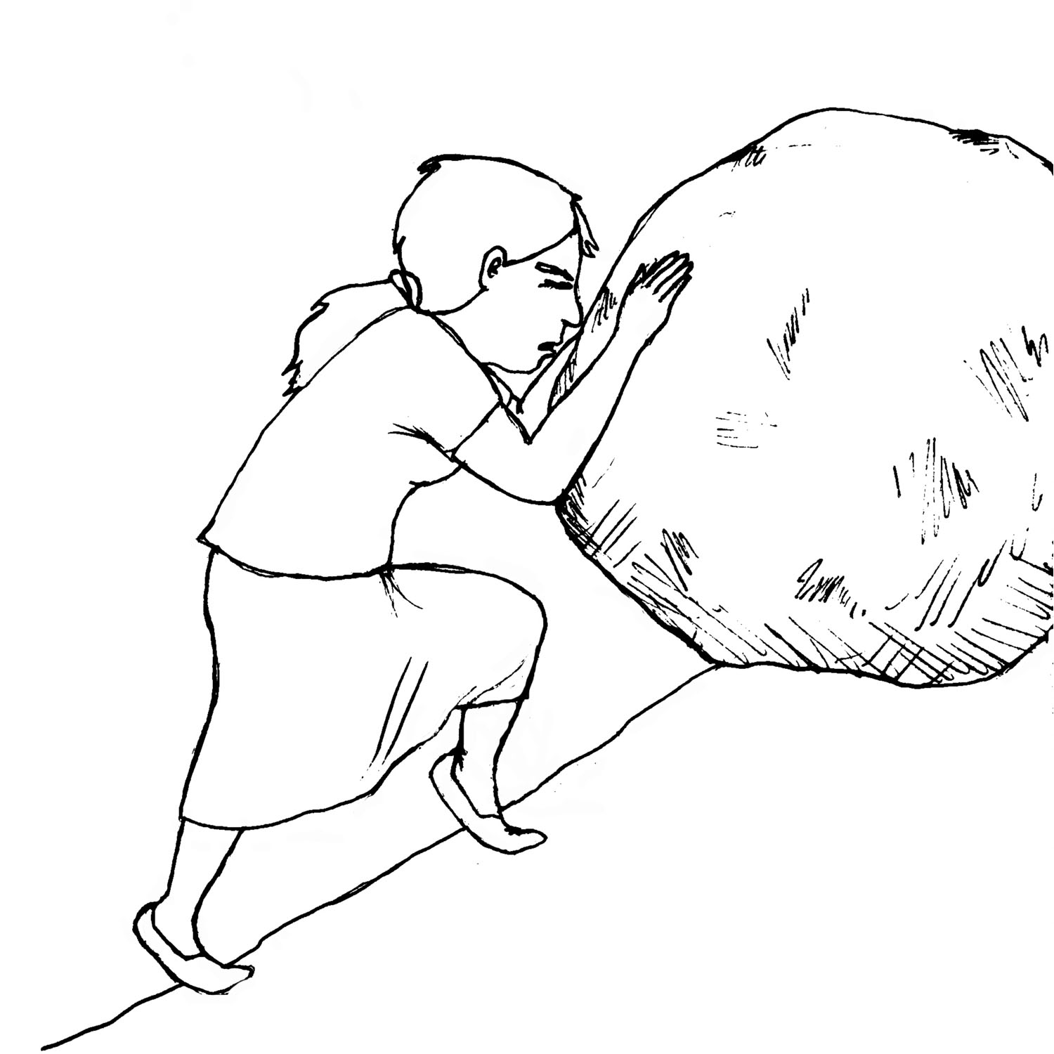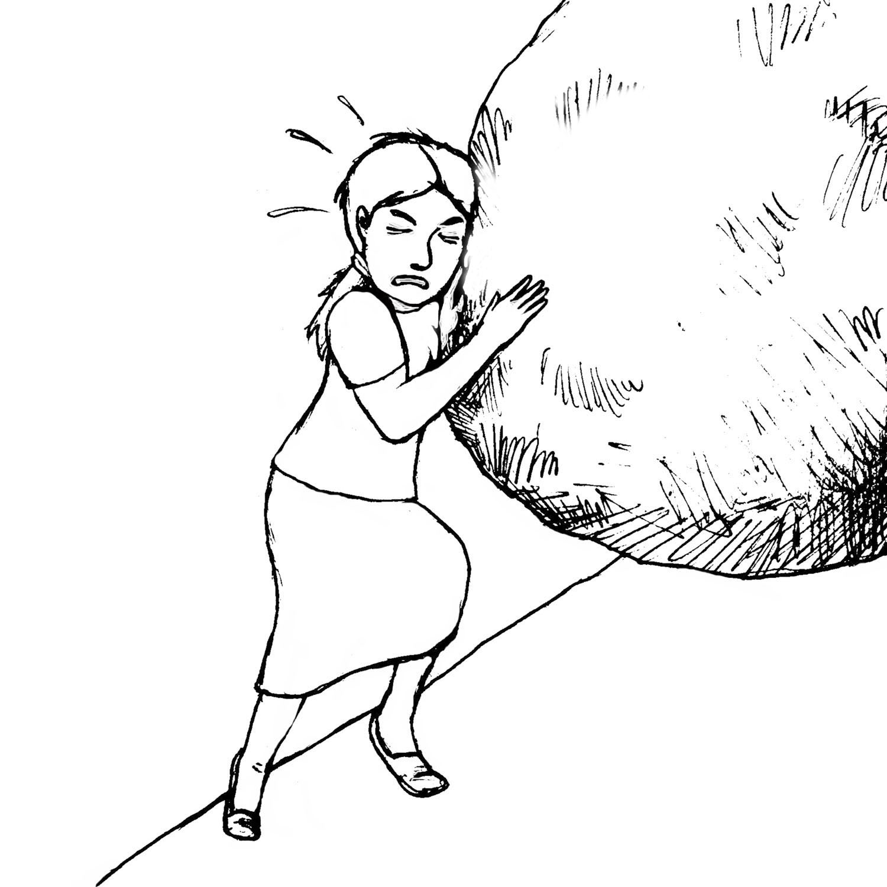

D8a. Before:
1 | 2 | 3 | 4 | 5

D8b. After:
1 | 2 | 3 | 4 | 5

Cooking Safety & Health

Read aloud to respondent:
Now I want to ask you some questions about your experience of health and safety risks while cooking in the past [6 months (1 year)].

I am going to name a health or safety risk, and I want you to tell me how frequently you or other members of your household have experienced it over the past [6 months (1 year)]. Please think of all of the different cooking methods and devices you use when answering these questions.

First ask “D9.” about option “a.” (concerning burns the respondent may have experienced).
If the respondent says YES, ask question “D10.”; if the respondent says NO, ask question “D11.” next.
Next, ask question “D11.”, about option “a.” (concerning burns for other household members).
If the respondent says YES, ask “D12.”; if the respondent says NO, move on to the next row (option “b.” concerning eye irritation).

 | YOU |  | OTHER HOUSEHOLD MEMBER
 | Over the past [6 months (1 year)], have you experienced ________?  1- Yes  2- No (skip to D11.) | If yes:  How frequently?  - Once in a while  - Sometimes  - Frequently  98- Don’t know | Over the past [6 months (1 year)], has another household member experienced _________?  1- Yes  2- No (skip to the next D9.) | If yes:  How frequently?  - Once in a while  - Sometimes  - Frequently  98- Don’t know
 | D9. | D10. | D11. | D12.
a. Burns

b. Eye irritation

c. Coughing and sneezing

d. Chest pains

e. Shortness of breath

f. Irritation of nose and throat

g. Other - Specify:

D13. | When you think about cooking now, compared to before you had the [clean cooking product/device], would you say you feel less safe, about the same, or more safe? | - Less safe  - About the same  - More safe  98- Don’t know  99- Not applicable

- Fuel Procurement: Expenditure, Time Use, Drudgery, and Safety

Fuel Procurement: Expenditure, Time Use, and Drudgery

Read out loud:
Now I am going to list some fuel types and I want you to tell me whether your household purchased this fuel, collected it, or both during [Season 1] only. This refers to the past [6 months (1 year)].

List out all the fuel types with regard to [Season 1] (these lines are in a light grey color). Ask whether the respondent purchased/collected any of the fuels listed during [Season 1] and mark the box in column “E1b.” either “Y” (yes) or “N” (no).

Once you have gone through the whole list of fuel types, read aloud:
Now I am going to read some more questions about the fuels that you collected or bought during [Season 1].

Start with the first fuel marked “Y” for [Season 1] and ask all the questions across that row (“E1c.” – “E1l.”).

When you have finished with a fuel type (e.g., purchasing charcoal) for [Season 1], ask the following:
Are there any differences in how much of this fuel you purchase/collect, the price, or anything else between [Season 1] and [Season 2]?

If the respondent answers YES, ask all the questions across the row marked “Season 2” for that fuel.

If the respondent says NO, you can simply copy his/her response from [Season 1] section to [Season 2] or just write “SAME” across the line.

Over the past [6 months (1 year)]
Fuel Type | Season | Did you purchase or collect [fuel type] in  [Season 1]?  Yes/ No  Did you purchase or collect [fuel type] in  [Season 2]? Yes/No |  | How frequently did you purchase/ collect the fuel? |  | Approximately how much did you purchase/ collect per fuel purchase/ collection trip? |  |  | How much did you  spend on each purchase?² (local currency)  (if applicable) | Who mostly gathered/ bought the fuel?³ 1- Woman  2- Man  3- Girl  4- Boy  5- Other/  house-help | Approximately how far did you/they travel per fuel purchase/ collection trip? (Km)¹  (Distance in one direction, not round-trip) | How much time did you/they spend on each trip?  (minutes)  (Round-trip) | How was the fuel normally transported?  1- Hands/purse  2- Head/back  3- Push bike  4- Donkey cart  5- Donkey, no cart  6- Car/bus/moped  7- Other  98- Don’t know
 |  |  |  | # of times | Per # of months | Quantity | Unit  (bundle, sack, bunch) | Kg per unit^{,2}
E1. | E1a. | E1b. |  | E1c. | E1d. | E1e. | E1f. | E1g. | E1h. | E1i. | E1j. | E1k. | E1l.
EXAMPLE: Wood | Rainy | Purchase? | Y | 1 time | 2 months | 1 | bundle | 20kg | 1400 KES | 1 | 2 km | 30 min | 5
 | Dry | Purchase? | Y | 2 times | 1 month | 1 | bundle | 20kg | 1200 KES | 1,3 | 7 km | 90 min | 1
Wood | Season 1 | Purchase?
 | Season 2 | Purchase?
Wood | Season 1 | Collect?
 | Season 2 | Collect?
Animal dung | Season 1 | Purchase?
 | Season 2 | Purchase?
Animal dung | Season 1 | Collect?
 | Season 2 | Collect?
Agricultural waste | Season 1 | Purchase?
 | Season 2 | Purchase?
Agricultural waste | Season 1 | Collect?
 | Season 2 | Collect?
Charcoal/ Coal | Season 1 | Purchase?
 | Season 2 | Purchase?
Charcoal/ Coal | Season 1 | Collect?
 | Season 2 | Collect?

Over the past [6 months (1 year)]
Fuel Type | Season | Did you purchase or collect [fuel type] in  [Season 1]?  Yes/ No  Did you purchase or collect [fuel type] in  [Season 2]? Yes/No |  | How frequently did you purchase/ collect the fuel? |  | Approximately how much did you purchase/ collect per fuel purchase/ collection trip? |  |  | How much did you  spend on each purchase?² (local currency)  (if applicable) | Who mostly gathered/ bought the fuel?³ 1- Woman  2- Man  3- Girl  4- Boy  5- Other/  house-help | Approximately how far did you/they travel per fuel purchase/ collection trip? (Km)¹  (Distance in one direction, not round-trip) | How much time did you/they spend on each trip?  (minutes)  (Round-trip) | How was the fuel normally transported?  1- Hands/purse  2- Head/back  3- Push bike  4- Donkey cart  5- Donkey, no cart  6- Car/bus/moped  7- Other  98- Don’t know
 |  |  |  | # of times | Per # of months | Quantity | Unit  (bundle, sack, bunch) | Kg per unit¹,
E1. | E1a. | E1b. |  | E1c. | E1d. | E1e. | E1f. | E1g. | E1h. | E1i. | E1j. | E1k. | E1l.
Briquettes | Season 1 | Purchase?
 | Season 2 | Purchase?
Briquettes | Season 1 | Collect?
 | Season 2 | Collect?
Pellets | Season 1 | Purchase?
 | Season 2 | Purchase?
LPG/Gas | Season 1 | Purchase?
 | Season 2 | Purchase?
Kerosene/ Paraffin | Season 1 | Purchase?
 | Season 2 | Purchase?
Electricity | Season 1 | Purchase?
 | Season 2 | Purchase?
Other (specify) | Season 1 | Purchase?
 | Season 2 | Purchase?
Other (specify) | Season 1 | Collect?
 | Season 2 | Collect?

E2. | When you think about the frequency of fuel collection/purchasing trips and/or the amount of time required to get fuel, now that you are using the [clean cooking product/device] (in addition to the [other cooking method(s) previously mentioned]), would you say it is less, about the same, or more than the frequency of fuel collection/purchasing trips and/or the amount of time required to get fuel before you had the [clean cooking product/device]? | - Less (Continue to below)  - About the same (skip to question E6.)  - More (skip to question E6.)  98- Don’t know (skip to question E6.)
E3. | How have you utilized the time saved? Δ  (Let the respondent list and choose the option that best matches his/her response)  If the respondent says income generation, ask questions E4. and E5.; otherwise skip to question E6. | - Taking care of children or other members of the household  - Helping children with their studies  - Working in the field  - Cleaning house/domestic tasks  - Income-generating activities (ask questions E4. & E5.)  - Social activities  - Leisure/ resting/ recreational activities  - Saved time too small to use for any specific purpose  97- Other (Specify:______________)  98- Don’t know
E4. | What is the income-generating activity you do?  (Ask this and the following question only if the respondent mentioned income generation in the previous question)
E5. | In an average month, approximately how much do you earn from this income-generating activity?  (If the respondent lists the amount per week, multiply by 4 to get the amount per month) | _____/ month  (local currency)

Fuel Procurement Drudgery

E6. | Read aloud to respondent: Now I want you to think about the level of effort required for fuel collection/ purchasing. I am going to ask you to use the pictures below to tell me about this level of effort. They represent a task that requires very little effort up to a task that requires an extreme amount of effort.  Please first point to the picture that matches the amount of effort you spent on getting fuel BEFORE you had the [clean cooking product/device], when you were only cooking only with the old method(s).  Please think of all of the different fuels you used before.  Mark down answer in the box below the picture that the respondent points to (“E6a.”).  Now, please point to the picture that matches the amount of effort you spend on getting fuel NOW that you are using the [clean cooking product/device] along with the [other cooking method(s) previously mentioned].  Please think of all of the different fuels you use now.  Mark down answer in the box below the picture that the respondent points to (“E6b.”).
E6a. Before:
1 | 2 | 3 | 4 | 5

E6b. After:
1 | 2 | 3 | 4 | 5

Fuel Procurement Safety

E7. | When you think about collecting/purchasing fuel now, compared to before you had the [clean cooking product/device], would you say you feel less safe, about the same, or more safe? | - Less safe  - About the same  - More safe  - Don’t know  - Not applicable

If respondent PURCHASES at least one kind of fuel, ask the following questions.

If the respondent DOES NOT PURCHASE any fuels, skip to section F.

E8. | When you think about the total amount of money you have spent on fuel for all your cooking devices in the past [6 months (1 year)], since you got the [clean cooking product/device], would you say it is less, about the same, or more than the amount of money you spent on fuel before you had the [clean cooking product/device]? | - Less (Continue to below)  - About the same (skip to section F)  - More (skip to section F)  98- Don’t know (skip to section F)
E9. | How have you utilized the money you have saved? Δ  (Let the respondent list and choose the option that best matches his/her response) | - School fees, school uniforms, school supplies, etc.  - Food or water  - Healthcare costs for household members  - Healthcare costs for self  - Home improvement (e.g., flooring, roofing)  - Household equipment/furniture  - Clothing or other household needs  - Transportation (e.g., bus rides, motorcycle rides, a new bicycle)  - Livestock  - Entertainment/leisure  - Investment in own business (e.g., buying materials, hiring workers)  - Money saved too small to use for any specific purpose  97- Other (Specify:______________)  98- Don’t know

- Income Earned through Productive Use of the Clean and/or Efficient Cookstove/Fuel (OPTIONAL)

F1. | Do you have a business in which you use a cookstove/cooking device? | - Yes  - No (skip to section G)
F2. | What cooking methods/devices do you use for this business? Δ  (Let the respondent list and choose the option(s) that best matches his/her response) | 1- Three-stone fire  2- Fixed mud stove  3- Local improved wood stove  4- High efficiency improved wood stove  5- Local improved charcoal stove (ceramic liner)  6- High efficiency improved charcoal stove  7- Traditional charcoal stove  8- Kerosene stove  9- LPG stove  10- Biogas stove  11- Electric stove  12- Briquette stove  13- Pellet stove  97- Other (Specify: _______________________)  - Don’t know
F3. | What fuels do you use for this business? Δ  (Let the respondent list and choose the option(s) that best matches his/her response) | 1- Wood  2- Animal dung  3- Agricultural waste  4- Charcoal/coal  5- Briquettes  6- Pellets  7- LPG/gas  8- Kerosene/paraffin  9- Electricity  97- Other (Specify: _______________________)  98- Don’t know

If the respondent does use [the organization]’s clean and/or efficient cookstove or fuel in his/her business, continue below (F4.).
F4. | As a result of using the [clean cooking product/device] as part of your business, are your earnings from your business less, about the same, or more as before you started using it? | 1- Less  2- About the same  3- More  98- Don’t know  99- Not applicable
F5. | What are some of the other changes that have occurred with your business as a result of using the [clean cooking product/device]? Δ  (Let the respondent list and choose the option(s) that best matches his/her response) | - More portable  - Cooks faster  - Requires less fuel  - Can produce a greater quantity of food/ products  - Attracts customers  - None  - Other (Specify:___________________)  - Don’t know

If the respondent does not use [the organization]’s clean and/or efficient cookstove or fuel in his/her business, skip to section G.
- Status

G1. | When you think about how people in your family and community look at you now, compared to before you had the [clean cooking product/device], would you say it is worse, about the same, or better? | - Worse  - About the same (skip to section H)  - Better  98- Don’t know
G2. | Why?  (Write down response)

- Customer Satisfaction (OPTIONAL)

H1. | What are the benefits you have experienced in your everyday life from the use of the [clean cooking product]?  (list up to 3) | Number 1: _____________________________________  Number 2: _____________________________________  Number 3: _____________________________________
H2. | What do you like most about the design or physical features of the [clean cooking product]?  (list up to 3) | Number 1: _____________________________________  Number 2: _____________________________________  Number 3: _____________________________________
H3. | Is there anything you wish you could change about the design or physical features of the [clean cooking product]?  (list up to 3) | Number 1: _____________________________________  Number 2: _____________________________________  Number 3: _____________________________________
H4. | If the [clean cooking product] broke, how likely would you be to pay to have it repaired? *  (List responses and let respondent choose) | - Extremely unlikely  - Somewhat unlikely  - Neither likely nor unlikely  - Somewhat likely  - Extremely likely
H5. | If the [clean cooking product] broke, how likely would you be to buy a new one? *  (List responses and let respondent choose) | - Extremely unlikely  - Somewhat unlikely  - Neither likely nor unlikely  - Somewhat likely  - Extremely likely
H6. | How likely are you to recommend this product to your friends or family? *  (List responses and let respondent choose) | - Extremely unlikely  - Somewhat unlikely  - Neither likely nor unlikely  - Somewhat likely  - Extremely likely
H7. | Why would/wouldn’t you recommend it?  (Write down response)
H8. | How many people have you recommended the [clean cooking product] to?  (Write in number) | __________

Read aloud to respondent: Thank you so much for your time!
Do you have any questions?

1 The units for weight and distance can be calculated according to the local context. ² If respondents have trouble providing either quantity or price of fuel, you can use local market prices to calculate. ³ Note: Here, numbers 1-4 refer to members of the household. School-going children at or below the age of 17 years are referred to as boys and girls, and above 17 years are referred to as men and women.
1 The units for weight and distance can be calculated according to the local context. ² If respondents have trouble providing either quantity or price of fuel, you can use local market prices to calculate. ³ Note: Here, numbers 1-4 refer to members of the household. School-going children at or below the age of 17 years are referred to as boys and girls, and above 17 years are referred to as men and women

