

**in Alliance   
Partner Countries**

**Catalyzing**

**Clean Cookstoves and Fuels Markets**

**GLOBAL ALLIANCE FOR CLEAN COOKSTOVES  
PARTNER COUNTRY TOOLKIT**

Dear partners and stakeholders,

Since its launch in 2010, the Global Alliance for Clean Cookstoves has made significant progress in its market-enabling activities, including research on the impacts of clean cookstoves and fuels on health, the environment, women’s empowerment, and livelihoods; the establishment of global standards for the sector; support for the enhancement of testing centers around the world; release of fund to support enterprise capacity building; the growth of partnerships globally; public outreach and advocacy to raise awareness of this silent killer; and more. While we are proud of our work on global interventions and our progress toward creating a global market for clean, safe, efficient, and affordable cooking solutions, we also recognize the importance of local and national progress and we are increasingly turning our attention to supporting market development in all of our partner countries. We very much value our partner countries and know that helping to facilitate progress in each country is essential to achieving universal access to clean cooking solutions.

Over the past two years, the Alliance has begun work in several partner countries where we have come to better understand what has been most helpful to partners in advancing their work in the clean cooking sector, in what areas we could improve our work, and what steps could be instrumental in facilitating greater collaboration within the sector. With these experiences and learnings in hand, the Alliance is now better positioned to share this knowledge and help all our partner countries learn from one another’s important work. The Alliance is committed to helping each of its partner countries coordinate their sector stakeholders, collect valuable information that will enable growth of the clean cookstove and fuel markets, and garner greater public and private support for action by providing the tools needed to make progress in each of these areas. These items fall into the following categories, and are available as attachments to this toolkit, along with the “10 Step Plan for Catalyzing a Clean Cookstoves and Fuels Market” outlined below:

* **Assess the current state of the cookstoves and fuels markets;**
* **Convene cookstoves and fuels stakeholders and interested parties;**
* **Identify barriers and develop an action plan to overcome them;**
* **Develop an engagement and communications plan;**
* **Adopt technology standards and commit to product testing;**
* **Drive investment and scale enterprises to meet consumer need;**
* **Connect the local cookstoves and fuels community with the global community;**
* **Track and report progress to evaluate success and areas for improvement;**
* **Learn from the progress and challenges of other countries; and**
* **Reevaluate necessary interventions by repeating the previous steps.**

We hope that this ten step toolkit and guidance from our own experience in developing Country Action Plans will help develop each of our partner country’s improved cookstove and fuels markets and enable all stakeholders to be more effective in their work. The tools and information provided in this document and the attachments, [available at this link](https://unfoundation.box.com/s/yljk8uqcyy4821t9j46r), are meant for many different kinds of partners and stakeholders, and some may find all the tools useful while others may target their attention to a few. We will also be providing a translations of this toolkit into Spanish and French to those who need them as it is completed. We are committed to helping all of our country partners make progress in developing their own thriving markets for clean cookstoves and fuels. We welcome your feedback on other areas that we could assist you in.

Best regards,

  
Radha Muthiah   
Executive Director  
Global Alliance for Clean Cookstoves

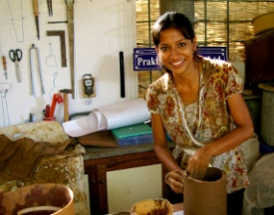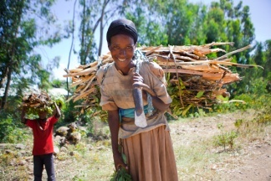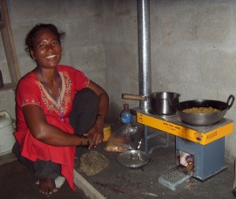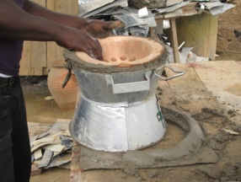

Note from the Global Alliance for Clean Cookstoves 2

Guide to Using the Partner Country Toolkit 6

Ten Steps to Developing the Clean Cookstoves and Fuels Markets 8

**Step 1: Assess the Current State of the Cookstoves and Fuels Market 16** 12

Information for Those Conducting the Market Assessment 18

Market Assessment Template 19

Interview Guides 21

Interview Guide: Government 21

Interview Guide: NGOs and Local Implementers 22

Interview Guide: Suppliers and Local Manufacturers 25

Interview Guide: Consumer Preference 25

Information for Those Interested in Contracting Out the Market Assessment 27

Sample Terms of Reference: Market Assessment of the Cookstoves and Fuels Sector 28

Sample Terms of Reference: Consumer Segmentation Study 32

Sample Score Sheet to Evaluate Proposals 36

**Step 2: Convene Cookstoves and Fuels Stakeholders and Interested Parties 37**

Draft Agenda for Initial Meeting of Cookstoves and Fuels Stakeholders 39

Information About Becoming a Global Alliance Affiliate Organization 40

**Step 3: Identify Barriers and Develop an Action Plan to Overcome Them 43**

Draft Agenda for Stakeholder Consultation and Strategic Planning Meeting 45

Barriers and Intervention Options: Identification Template 46

Country Action Plan Template 47

Country Action Plan: Cover 48

Country Action Plan: Table of Contents 49

Country Action Plan: Executive Summary 50

Country Action Plan: Actionable Intervention Options 51

Country Action Plan: Targets/Key Performance Indicators 53

Country Action Plan: Conclusions/ Next Steps 54

Country Action Plan: Appendices 55

Implementation Plan Template 59

**Step 4: Develop an Engagement and Communications Plan 61**

National Priority Mapping Template 63

Ideas for Ways to Engage the Government 64

Communications Plan Template 65

Awareness Raising Factsheets 66

Cookstoves in (Partner Country Name) 67

Cookstoves and the Environment 68

Cookstoves and Women’s Empowerment 69

Cookstoves and Health 70

**Step 5: Adopt Technology Standards and Commit to Product Testing 71**

International Organization for Standardization Member Information 73

List of Global Testing Centers 74

**Step 6: Drive Investment and Scale Enterprises to Meet Consumer Need** 77

Investment Readiness Checklist 80

Business Plan Outline for an Emerging Markets Product/Access to Energy Business 82

**Step 7: Connect the Local Cookstoves and Fuels Community with the Global Community 86**

Community Section of the Alliance Website 88

Global Partner Directory 89

Communities of Practice 90

Open Discussion Pages 91

**Step 8: Track and Report Progress to Evaluate Success and Areas for Improvement 92**

Results Reporting Framework 93

Other Ideas for Encouraging Monitoring and Evaluation 95

**Step 9: Learn from the Progress and Challenges of Other Countries 96**

Alliance Plans to Connect Country Partners 97

**Step 10: Reevaluate Interventions by Repeating Steps 1 Through 9 98**

The Importance of Reevaluating Interventions for Continued Improvement 99

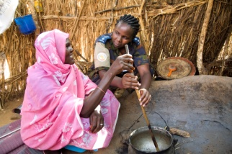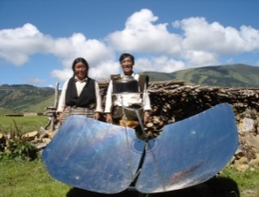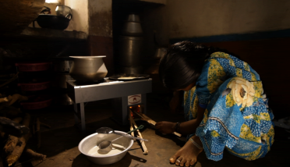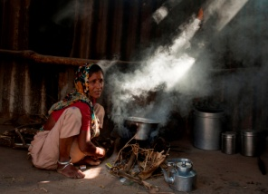

Based off of the Alliance’s experience working in many of its partner countries over the last two years, we have found that our work in the following areas has had the most impact towards furthering market development and has been the most helpful for our partner organizations.

**Market intelligence:**

After gathering market intelligence in more than fifteen countries and holding several stakeholder meetings, the Alliance has seen the immense value in mapping the need for clean cooking solutions as well as facilitating discussion about ongoing sector activities at the country level. In order facilitate the collection of this type of information globally and to prompt discussion among stakeholders about identifying and tackling the sectors’ needs, the Alliance is providing all of its partner countries a set of tools that will allow them to evaluate their current cookstoves and fuels markets, including market assessment tools, market assessment presentation materials, and consumer preference questionnaires.

**Sector coordination:**

Our stakeholder meetings and planning workshops proved that gathering partners who are working toward a common goal can help coordinate their work, reduce duplication, and become collectively more effective. To help facilitate this process in other partner countries, we will provide Country Action Plan templates, implementation plan templates, as well as information about forming a national alliance that can act as a coordinating body for all stakeholders. We will also continue to support the convening of partner organizations within partner countries and regionally, both through in person meetings and through the online community available on our website that can be used for sharing best practices, lessons learned, and coordinating action at the country level.

**Awareness-raising:**

The Alliance has seen the importance of bringing this issue to the forefront of the global agenda in terms of both resource mobilization and of government prioritization. We know that it is essential to raise awareness with accurate and compelling information at multiple levels within a country – national, state and province, as well as for communities and households to enable a market and ensure sustainable adoption. In order to continue raising awareness of this important issue at the country level, the Alliance will provide awareness raising materials that are specific to your country, including materials related to health, the environment, women’s empowerment, and economic impact with data and other information that demonstrates the use of traditional cookstoves and conveys the need for action. The Alliance also has webpages with specific information by country at [www.cleancookstoves.org/countries](http://www.cleancookstoves.org/countries/).

**Lessons learned:**

Beyond facilitating the sharing of in-country information, the Alliance will work to connect partner countries to other countries that have similar developmental and socio-economic characteristics, so that they can share information about what types of actions have been successful at growing their own improved cookstoves and fuels markets. This will allow partner countries to learn from one another’s experiences and better position them to avoid mistakes of past efforts.

With these areas of experience and feedback from our partners, the Alliance has put together the following ten step process to further develop the improved cookstoves and fuels markets in our partner countries.

# 

# IMG_0878.JPGGuatemala_Marie Clara high res.tifroad to buyaka 014.jpgcid:FE27427B-4215-4803-A5D1-3DB2C17DD88B@hsd1.ms.comcast.net.

# 0

**1**

[**Step 1: Assess the Current State of the Cookstoves and Fuels Market**](#_Step_1:_Assess_2)**s**

*Objective: Understand the current state of the cookstoves and fuels markets in order to better inform stakeholder decisions, spur private sector investment in manufacturing and distribution of cookstoves and fuels, advise governments and national policymakers, and inform donors and investors.*

Use the Alliance’s market assessment toolkit to assess the current state of the cookstoves and fuels market in your country in order to better inform private companies, NGOs, and government stakeholders. This will include conducting interviews with stakeholders and gathering data to better understand the ongoing work in the sector, including the successes and challenges of current stakeholders, and will better position stakeholders to identify where efforts and resources should be focused. You can also hire a market research firm or consultant to conduct the assessment for you.

**Market assessment tools:**

*For those who are interested in conducting the market assessment:*

* Tools for evaluating and analyzing:
  + Macro environment factors ([attached](https://unfoundation.box.com/s/6nqfvxochxr7d61jwme0))
  + Household air pollution and its impacts ([attached](https://unfoundation.box.com/s/6nqfvxochxr7d61jwme0))
  + Consumer demand and consumer segments ([attached](https://unfoundation.box.com/s/6nqfvxochxr7d61jwme0))
  + Cookstove and fuel industry activity and maturity ([attached](https://unfoundation.box.com/s/6nqfvxochxr7d61jwme0))
  + Carbon financing opportunities and challenges ([attached](https://unfoundation.box.com/s/6nqfvxochxr7d61jwme0))
* Interview guides for NGOs, local implementers, government representatives,   
  cookstove suppliers, and cookstove manufacturers
* Focus group discussion gender guide ([attached](https://unfoundation.box.com/s/6nqfvxochxr7d61jwme0))
* PowerPoint template for presenting market assessment information ([attached](https://unfoundation.box.com/s/6nqfvxochxr7d61jwme0))
* Questions for consumer preference survey

*For those who are interested in finding a research firm to conduct the assessment:*

* Sample terms of reference for conducting a market assessment
* Sample terms of reference for conducting a consumer segmentation study
* Sample score sheet to evaluate proposals

**2**

[**Step 2: Convene Cookstoves and Fuels Stakeholders and Interested Parties**](#_Step_2:_Convene)

*Objective: Bring together stakeholders to facilitate greater collaboration within the sector and to form a representative body that can collectively engage outside actors. This can help to ensure that parties are aware of each other’s efforts to grow the market, learn from past mistakes, limit duplication, and strengthen joint engagement.*

Through the market assessment (Step 1) and with the Alliance’s assistance providing information on those partners who are located and working in each partner country, gather all relevant stakeholders to discuss common challenges and opportunities. From past experience, we have learned that it is often very useful for this group to form a body that can act as an industry representative organization, and can meet to accomplish subsequent Steps 3 and 4. Alternatively, this group could commit to meeting regularly, without committing to the formation of a representative body.

**Convening sector information:**

* List and description of partners working in the partner country (contact the Alliance for this information)
* Draft agenda for initial meeting of cookstove and fuel stakeholders
* Presentation on global cookstoves and fuels issue ([attached](https://unfoundation.box.com/s/6nqfvxochxr7d61jwme0))
* Information about becoming a Global Alliance affiliate organization

**3**

[**Step 3: Identify Barriers and Develop an Action Plan to Overcome Them**](#_Step_3:_Identify)

*Objective: Identify the barriers currently preventing adoption of improved cookstoves and fuels, develop an action plan for addressing these barriers, and agree to a common plan for implementing the identified actions as a means to catalyze the market.*

After convening sector stakeholders (Step 2), work with this group to identify key barriers to the adoption of clean cooking solutions at scale within each partner country, as well as potential intervention options and mechanisms for quickly and effectively taking action to address these barriers. This information can be put into a Country Action Plan, which other Alliance country partners have found useful to organize information about the specific needs of their own improved cookstove and fuels market development. Finally, with the Country Action Plan in place, the group can develop an implementation plan to turn the strategies and interventions into concrete action.

**Country action organization tools:**

* Draft agenda for initial Country Action Plan meeting
* Barriers and intervention options identification template
* Country Action Plan template
* Implementation plan template

**4**

[**Step 4: Develop an Engagement and Communications Plan**](#_Step_5:_Develop)

*Objective: Increase the interest of governments, donors, and investors by developing a strategic plan for engagement and a communications plan to drive general awareness raising at multiple levels .*As a Country Action Plan is developed, an engagement strategy for the government and an action plan for increasing the interest of donor organizations and investors should also be established. Advocating on behalf of the broader sector as one representative body (Step 2) instead of several individual organizations will ensure that the voice of the sector is heard. The Country Action Plan (developed in Step 3), which clearly lays out the need for action within the improved cookstove and fuels markets, can be used as a tool to advocate on behalf of the sector or in resource mobilization activities with donors. For government engagement, the national priority mapping template will also allow stakeholders to identify where the priorities of the sector align with national priorities for more effective communication with the government and within the government. Additionally, the Alliance has prepared several factsheets that can be used as general awareness raising materials and in meetings with the government or other interested parties.

**Engagement strategy materials:**

* National priority mapping template
* Ideas for ways to engage the government
* Communications plan template
* Overview of issue one pager
* Health impact one pager
* Empowering women one pager
* Environmental one pager

**5**

[**Step 5: Adopt Technology Standards and Commit to Product Testing**](#_Step_6:_Adopt)

*Objective: Adopt a standard that all cooking technologies must meet in order to help consumers understand cookstove performance and value; to provide policy makers, donors, investors and other stakeholders with a basis for comparing cookstove performance and safety; and to drive innovation in the industry.*

Alliance partner countries should participate in the standards development process to ensure that standards are relevant for their region. Partner countries should evaluate the International Standards Organization (ISO) International Workshop Agreement (IWA) guidelines for cookstove performance and any future international standards, adapt if necessary, and adopt so support a globally integrated standards and testing system. Partner countries should also develop a strategy to test, report, certify, and/or label cookstoves based on their performance, and enforce these standards using a system that is harmonized with the international reporting framework. Each country should also coordinate organizations in reporting independent testing results of cookstove performance and quality, in line with ISO IWA, in a standardized and transparent way so that results could be made accessible to stakeholders and donors to allow optimum funding allocation.

**Cookstove standards and testing information:**

* International Standard Organization member information
* International Workshop Agreement IWA 11:2012 ([attached](https://unfoundation.box.com/s/6nqfvxochxr7d61jwme0))
* Interim reporting requirements for IWA Tiers of Performance ([attached](https://unfoundation.box.com/s/6nqfvxochxr7d61jwme0))
* List of global testing centers

**6**

**Step 6: Drive Investment and Scale Enterprises to Meet Consumer Need**

*Objective: Ensure that the markets for clean cookstoves and fuels in partner countries are sustainable and that the products meet consumer needs.*

The strategy of any Country Action Plan (Step 3) will likely prioritize a range of activities to enable markets, including: attracting more social and retail investment into the sector; reducing barriers for cookstove enterprises to access carbon financing; driving technological innovation; supporting enterprise development; and generating demand through increased consumer awareness and availability of consumer financing, as needed. This approach enables the market to transition from donor and other forms of ‘soft’ financing to attract private investment and achieve scale. Additionally, whether the products and fuels are locally produced or internationally manufactured, it is essential that they meet consumer needs in terms of affordability, availability, and cooking style to ensure long-term adoption.

**Building enterprise capacity tools:**

* Investment readiness checklist for businesses
* Business plan outline
* Carbon financing portal (currently in development)
* Database of cookstove and fuel enterprises for investors (currently in development)
* Development of globally recognized impact investing indicators for the sector (currently in development)
* Access to enterprise building and working capital funds

**7**

[**Step 7: Connect**](#_Step_7:_Connect) **the Local Cookstoves and Fuels Community with the Global Community**

*Objective: Learn from others in the sector, both within your country and internationally, through lessons learned, best practices, and case studies, as well as share relevant research and other findings with the global community.*Keeping your own stakeholder community well connected, both as a group and with the Global Alliance, will be essential to ensuring good communication and collaboration throughout this process. There are several means with which to do this, including creating a Community of Practice on the Global Alliance’s website. Additionally, the Alliance will provide information on how to develop a country portal in the coming months. Beyond connecting with stakeholders in your country, we have found that providing a means by which stakeholders globally can connect with one another to share lessons learned and best practices has been invaluable. To accomplish this, the Alliance has developed a website that not only provides information to the global cookstoves and fuels community, but also allows its partners to engage with one another through several different mediums to share information, ask questions of one another, and learn from past experiences.

**Community connection tools:**

* Partner community web pages
* Online global partner directory
* Communities of practice
* Open discussion pages

**8**

[**Step 8: Track and Report Progress to Evaluate Success and Identify Areas for Improvement**](#_Step_8:_Track)

*Objective: Establish a baseline to inform progress towards the goal of clean cookstoves and fuels adoption, and ensure proper monitoring and evaluation practices.*After strategically planning for the work needed to develop the improved cookstoves and fuels markets in your country, it is essential to track and report the progress so that as a group you can evaluate areas of success and areas for improvement. Clearly understood and transparent indicators should be used that can measure results from the most basic project parameters like cookstove sales, adoption rates, household air pollution, fuel collection time, and fuel and cost savings, to broader objectives regarding saving lives, empowering women, improving livelihoods, and protecting the environment. The Alliance has developed a results reporting framework that can be used by stakeholders to monitor their work and in the near future will also provide stakeholders with online tools that will increase the ease with which they are able to track this information.

**Monitoring and evaluation tools:**

* Results reporting framework ([attached](https://unfoundation.box.com/s/6nqfvxochxr7d61jwme0))
* Ideas about other ways to encourage monitoring and evaluation

**9**

[**Step 9: Learn from the Progress and Challenges of Other Countries**](#_Step_9:_Learn)

*Objective: Facilitate communication and cross border learnings.*While we encourage stakeholders to learn from one another through the Community section of the Alliance’s website and at the Alliance’s regional and global events, the Alliance will also work in the coming months to connect each partner country to other countries that have similar developmental and socio-economic characteristics. By analyzing these factors and closely examining markets by country, the Alliance can connect countries so that they can share useful and applicable information about what types of actions have been successful at growing their improved cookstoves and fuels markets. Note: reporting to the Alliance on progress and challenges will be important in helping us evaluate where lessons learned could be the most applicable.

**Learning from other countries:**

* Annual Regional Forums
* Biennial Global Forum
* *Alliance will be in touch with you about this step in the coming months as we prepare this analysis for all of our partner countries.*

**10**

[**Step 10: Reevaluate Necessary Interventions by Repeating Steps 1 through 9**](#_Step_10:_Reevaluate)

*Objective: Ensure that the sector is using the most relevant information, monitoring its work, and seeking continued improvement by repeating the previous steps every three years.*

In a growing and evolving market and field such as improved cookstoves and fuels, it is essential that the sector is able to keep up with new innovation, information, and insights. To make sure that each country’s consumers are able to benefit from the latest technological advances in areas like cleanliness and safety, as well as to make sure that business practices and policy decisions are using the most up to date information, the sector should repeat the steps outlined above every three years.

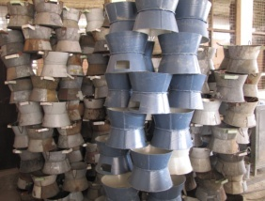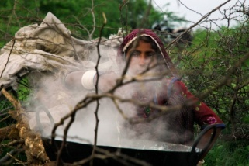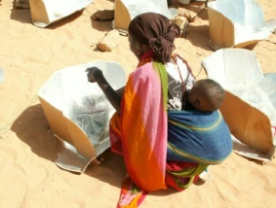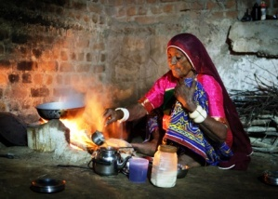

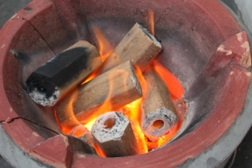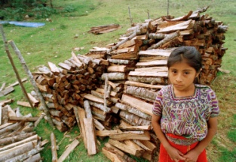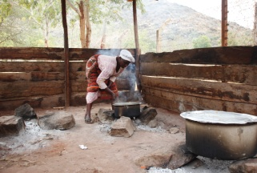

## About the market assessment toolkit:

The market assessment toolkit provides all of the tools needed to conduct a cookstove and fuel industry market assessment. It includes an easy to use, step-by-step guide to help organisations evaluate their cookstoves and fuels market, better understand customer needs, and identify the barriers to establishing a more robust national clean cooking industry. It also includes some tools which will help you analyze the information that you’ve collected to better inform stakeholder efforts, and provides an easy template that you can use to present all of the information after it has been collected. The toolkit provides sample answers for each question, so that the user can get a sense of what types of information would be especially useful to include in the assessment.

This information can be utilized by anyone – a stakeholder who is interested in conducting the study, a government ministry interested in exploring the sector, or it can be given to a research firm that is selected to perform the assessment to aid them in their work. In many cases, this type of project could be best or most efficiently undertaken by a national or regional alliance or coordinating body.

**Tools and information included in this step:**

* Tools for evaluating and analyzing:
  + Macro environment factors ([attached](https://unfoundation.box.com/s/6nqfvxochxr7d61jwme0))
  + Household air pollution and its impact ([attached](https://unfoundation.box.com/s/6nqfvxochxr7d61jwme0))
  + Consumer demand and consumer segments ([attached](https://unfoundation.box.com/s/6nqfvxochxr7d61jwme0))
  + Cookstove and fuel industry activity and maturity ([attached](https://unfoundation.box.com/s/6nqfvxochxr7d61jwme0))
  + Carbon financing opportunities and challenges ([attached](https://unfoundation.box.com/s/6nqfvxochxr7d61jwme0))
* Interview guides for NGOs, local implementers, government representatives,   
  cookstove suppliers, and cookstove manufacturers, and consumers
* PowerPoint template for presenting market assessment information ([attached](https://unfoundation.box.com/s/6nqfvxochxr7d61jwme0))
* Sample terms of reference for market assessment
* Sample terms of reference for consumer segmentation
* Sample score sheet to evaluate proposals

**Information for Those Conducting the Market Assessment:**Before starting, one approach that the Alliance has found helpful is to look through all of the market assessment toolkit spreadsheets to see what types of information will be needed, and then to take stock of all of the existing sources of information before sifting through the information more carefully. This way, you have a sense of which areas are rich in available information and which areas might require more targeted research, allowing you to simultaneously fill in the toolkit and find additional information sources.   
  
One good source of information available in many countries is national survey data, taken by the government every few years. This type of survey data often includes basic information about the general population, including dispersion of the population within the country, income levels, solid fuel use, and other relevant information. This information is often publically available, and if not it can often be formally requested. After looking up survey data, it may be helpful to do a literature review to see if any published studies have been conducted regarding cookstoves or fuels in your country. One easy way to do this is to put your search query into [**Google Scholar**](http://scholar.google.com/), the arm of Google that indexes the full text of scholarly literature across many publishing formats and disciplines on a complimentary basis.  
  
After conducting the initial review of existing data sources, interviewing relevant stakeholders within the improved cookstove and fuel sector will provide you with much of the qualitative data that you need to better understand the context of the market. Use the following interview guides as a starting place for evaluating the market during interviews with sector stakeholders. Please note that while these guides will help start this process, they are not meant to be comprehensive and should be used only as a guide.

**Who are you looking to interview?**

**Select one:**

* [Government representative](#_Interview_Guide:_Government)
* [NGO or local implementer](#_Interview_Guide:_NGOs)
* [Manufacturer](#_For_suppliers_and)
* [Consumer or end-user](#_Interview_guide:_Consumer)

Factors to consider throughout the assessment include, but are not limited to: differences in usage of cookstoves and fuels between women and men; urban and rural consumers; income classes; fuels used and available; and household cooking needs.

**Market Assessment Template:**

While the majority of the market assessment toolkit exists in the [attached](https://unfoundation.box.com/s/6nqfvxochxr7d61jwme0) spreadsheets, we have put a few sample questions in this document so that you get a sense of the areas that the toolkit will cover.

**The market assessments are meant to cover topics such as:**

* Current household air pollution (HAP) exposure and HAP awareness level;
* Macro context of the market including demographic, social, gender, political, economic and ecological conditions and trends;
* Profile of female and male consumer behavioral patterns and prioritized drivers of choice, including price sensitivity and accessibility;
* Cooking device industry overview, including cooking devices currently used, main designers and suppliers, commercial viability of the sector, and potential for livelihood creation for both women and men in the value chain;
* Estimation of potential market size for clean cookstoves and fuels and market segmentation to understand where to focus efforts and social marketing activities;
* Identification of key fuel issues for both male and female users within different consumer segments, such as time spent in fuel collection, cost of fuel, etc.;
* Options analysis of supply chain and distribution scenarios – who produces / provides required products and services, how are they distributed to the final consumer, who are the “players” (male and female) in the value chain and what is their role within it;
* Evaluation of potential sources of financing for clean cookstoves and fuels businesses and suppliers, as well as for consumer financing, and key constraints in accessing financing;
* Carbon finance opportunities and current projects;
* Key barriers and constraints identified by local stakeholders to adapting programs to produce cleaner cookstoves and fuels, if appropriate;
* Identification of key constraints to the scale-up of existing cookstove and fuel programs (if any);
* Identification of key constraints identified by local stakeholders to including cookstoves and fuels in existing programs in other relevant sectors;
* Evaluation of policy frameworks for energy, household energy, gender, and development;
* Identification and review of existing improved cookstove and fuel initiatives, including organizations, scope, key actors involved, and lessons-learned, especially with regard to reasons for success or failure to scale up distribution and use of improved cookstoves in a region;
* Identification of best practices and lessons learned in design, production, and distribution; and
* Identification of successful campaigns, distribution chains, and institutional models that reached the last mile, particularly in design, distribution, and livelihood creation, in past cookstove and fuel projects and/or in relevant sectors (i.e. sanitation, solar lanterns, etc.).

The templates are broken up into five different spreadsheets and cover topics in the following areas:

**Macro environment:**

* Political: What level of political support or resistance are cookstove and fuel initiatives likely to encounter?
* Economic: What is the cost of financing? Is the business environment favorable for a clean cookstove and fuel industry?
* Social: How does social environment impact demand, supply, and competition?
* Technological: How sophisticated is the infrastructure in our region and how will technologies and ideas received?
* Ecological: How does the ecological environment impact household air pollution or biomass use?
* Alliance Partners: Who are the Alliance partners that are actively involved in this country?

**Household air pollution analysis:**

* What is the current household air pollution exposure profile of our target market?
* What lessons can we learn from historic and existing household air pollution programs?
* Who are the key actors involved in household air pollution programs?

**Customer segmentation:**

* What is the profile of the target population?
* How can the customer population be segmented/categorized?
* How many people are in each customer segment and what are its characteristics?
* What are the specific needs of each customer segment?

**Cookstove industry analysis:**

* What cooking devices and fuel types are currently owned and used within the country/ region?
* Who are the key stakeholders involved in the cookstove and fuel industry value chain?
* How attractive is the industry from a commercial perspective and what are some of the industry challenges?

**Carbon financing:**

* What are the factors that determine carbon finance eligibility?
* What are the criteria that determine Clean Development Mechanism (CDM) vs. voluntary eligibility?
* Are there possible alternative activities that could complement existing activities and result in greater output?
* Are there existing cookstoves carbon finance projects or a Program of Activities that could be used for comparisons?
* Are there any carbon finance cookstove projects in the registration process?

**Interview Guides:**

***Please find the*** [***attached***](https://unfoundation.box.com/s/6nqfvxochxr7d61jwme0) ***“Market Assessment” spreadsheet files for the full toolkit.***

Below are interview guides for different types of stakeholders. Use the following interview guides as a starting place for evaluating the cookstove and fuel markets during interviews with sector stakeholders.

**Who are you looking to interview?**

**Select one:**

* [Government representative](#_Interview_Guide:_Government)
* [NGO or local implementer](#_Interview_Guide:_NGOs)
* [Manufacturer](#_For_suppliers_and)
* [Consumer or end-user](#_Interview_guide:_Consumer)

**Interview Guide: Government**

* History of policies related to cookstoves and household energy products
  + What national policies have been previously used to encourage adoption of household energy technologies?
  + How have market-based approaches and government-controlled approaches been used?
  + What financing models has the government used or supported for new initiatives?
  + What is the government approach to using international investment?
* Past and current household energy product support
  + What technologies, services, or products have been previously supported by the government? How has the government supported them?
  + What are the capabilities of the government for supporting local businesses or private enterprises?
  + How do the different layers of governments need to work together?
  + Which government ministry or agency is best suited to support clean cookstoves and fuels?
  + Which ministry is best positioned to lead on clean cookstoves and fuels work?
* Distribution infrastructure capabilities
  + What distribution options exist in the country?
  + What are the major challenges to distribution?
  + Who might you need to partner with to access these distribution channels?
  + How have government marketing channels and infrastructure been utilized for publicizing past government priorities?
* Other initiatives
  + What other initiatives are being proposed?
  + How do these relate to clean cookstove and fuels initiatives?
  + Could government support span these initiatives?

**Interview Guide: NGOs and Local Implementers**

* Cooking habits
  + What are the primary foods cooked by the local population?
  + What cookstove requirements, if any, does this diet imply? Examples: simmering, boiling, long cooking periods, need to control heating intensity, accommodation of different pot sizes and shapes, etc.
* Fuel availability
  + What fuels are available, or can be made available, in the country? For each:
    - What are the current and potential prices?
    - What is the current penetration and usage profile?
    - What challenges to usage exist? (Distribution, upfront investment, safety, cookstove requirements, sourcing/procurement, etc.)
    - For new fuels, what is the timeline for their availability or widespread distribution?
    - What sort of income displacement, employment displacement, or other negative effect could result from a fuel switch? How can this be addressed?
* Cookstove material availability
  + What stove-making materials are available in the country (metals, clay, etc.)?
  + What are the prices of the various options?
  + Distribution considerations for each option – are they available in all parts of the country?
  + Complexity of supply/manufacture/assembly?
* Manufacturing capability
  + What capabilities for manufacturing exist in-country?
    - Potting
    - Basic metals/workshops
    - Advanced manufacturing/assembly
    - Access to prefabricated metals or other materials
* Distribution infrastructure capabilities
  + What distribution options exist in the country?
  + What are the major challenges to distribution?
  + Who might you need to partner with to access these distribution channels?
* Income levels and ability to make upfront investments
  + What is the typical fuel procurement method for families in-country? For example, is fuel purchased or collected?
  + What percentage is purchased vs. collected?
  + How much time is typically spent collecting fuel?
  + How do families feel about purchasing alternative fuels?
  + How many days of fuel are typically purchased at a time?
  + Are families able to support the upfront purchase of fuel? If so, how much?
* Awareness of health issues
  + What level of household air pollution awareness currently exists in the country?
  + What challenges does an awareness campaign face?
  + How concerned are families with the health risks from exposure to smoke from use of solid fuels?
* Most effective methods of communication
  + What is the most effective means of reaching the general or target population?
  + How should a successful marketing campaign best utilize these channels?
  + Is there anyone with whom you should partner to get a message out?
* Most influential actors (religious, government, schools)
  + Who are the influential actors in the country who could be utilized for raising awareness?
  + What level of support could you expect from these actors?
  + How should a successful awareness raising campaign best incorporate these actors?
* Cultural sensitivities or considerations
  + How are current cooking practices perceived by the target population?
  + Are there any negative cultural implications to alternative fuel choices?
  + Are there any cultural sensitivities or other considerations that you should be aware of?

***For local implementers with previous program experience:***

* Motive and entry mindset
  + What was the motivation behind the previous program(s)?
  + Who were the primary sponsors/donors/etc.? How did this affect the scope or goal of the program?
  + Who did you partner with in-country and how did you select your partners?
* Target market identification
  + How did you select the target market for the program?
  + What research was conducted prior to entering the market?
* Product / fuel selection
  + How did you select the product and fuel for the program?
  + What research was conducted prior to making this decision?
  + What were the pros and cons of the various product options?
  + Would the decision have changed with additional funding or logistical/partner support?
* Market entry and program launch
  + What strategy was employed to enter the market?
  + How did the program launch? (national media event, village tours, etc.)
  + Were certain geographies launched before others? How were these geographies selected?
  + What challenges did the program experience in the initial phases?
* Awareness and marketing
  + Did the program attempt to increase awareness of household air pollution? How did it go about this?
  + How did the program market the solution to the target population?
  + What channels were used?
  + How effective was the campaign?
  + How critical was marketing to the program’s success or failure?
  + What were the major challenges to awareness and marketing efforts?
* Adoption and scalability
  + What was the rate of adoption experienced by the program?
  + How could this rate be improved? What were major limitations?
  + How scalable was the program? Could it have been rolled out across more locations?
  + How sustainable was the program?
    - Was the model meant to be commercially-viable?
    - By what amount, if any, did the program need to be subsidized in order to operate?
    - What would allow the program to become fully commercially sustainable?
* Carbon Financing
  + Did the program utilize any carbon financing?
  + What mechanism was used?
  + Who were the carbon finance program partners?
  + What challenges did the carbon financing component face?
  + What work was accomplished that could be leveraged for a future carbon finance program?
* Current Situation
  + Where does the program stand today?
  + What opportunities exist to leverage the previous program or its partners?
  + What other lessons have been learned which we should be sure to incorporate in any future programs?

**Interview guide: Suppliers and Local Manufacturers**

* What are the possible fuel/cookstove supply options, in your view?
  + Availability of materials
  + Manufacturing capabilities and limitations
  + Distribution capabilities and limitations
  + Pricing
* What would the cost be for each option?
* How complex is assembly for the various stove options?
  + How much skilled labor involved?
  + Is this labor available?
  + Cost to import cookstove parts vs. assembling in-country?
  + Cost to import finished cookstoves vs. assembling in-country?
* What are the distribution options?
  + What are the current distribution capabilities and limitations?
  + What distribution partners do you currently use?
    - Can these current partners reach the target population?
  + What other partners are available?
  + What other distribution considerations need to be made given the target population?

**Interview guide: Consumer Preference**

* What cookstoves and fuels are currently being used and/or purchased by the segment (note: multiple cookstove or fuel use within a single household should be noted, and primary technology use should be inquired)?
* What are the reasons that people use and/or purchase this cookstove and fuel combination?
* How much does the currently used cookstove and fuel (both upfront and ongoing) cost?
* What current consumer financing models are being utilized or what other means of purchasing the product are used?
* Where this consumer segment purchased or otherwise acquired the cookstove?
* What are the reasons for not using and/or purchasing other types of cookstoves and fuels?
* What are some current household economic indicators that show current household expenditures?
* Does this population have access to and interest in other modern household goods such as mobile phones?
* What is the motivation for purchasing new products, including luxury goods such as televisions as well as those in the price range of an improved cookstove (if applicable, motivation for those segments purchasing products for use by another party);
* For aspirational goods, where did the motivation to purchase this originate? How did they save for or purchase them?
* How are purchasing decisions made within a household? What factors are taken into account, where are goods purchased, and how they are financed?
* Are there non-tangible drivers of product purchase, such as social or cultural factors that could motivate a consumer to purchase and/or adopt a product?
* What marketing messages, techniques, channels are currently being used to target this segment; what are the most effective and how is that effectiveness measured?
* What are some currently utilized distribution chains reaching this segment, for cookstoves and for other products, including the size and weight of products?
* Are there any active cookstove and fuel stakeholders trying to reach this segment, including their scale, their main challenges, and their main factors of success?

**Information for Those Interested in Contracting Out the Market Assessment:**We have included here several samples of documents that will help you find and select a firm to conduct the market assessment, including sample terms of references for different types of research and a sample score sheet for evaluating the proposals.   
  
From our experience, we have found it helpful to include the research teams conducting the market assessments in the cookstoves and fuels stakeholder meetings (Step 3) so that they are able to test their assumptions and hypotheses about the sector with stakeholders in person, as well as listen to the sector’s feedback. For this reason, it would be advantageous to plan the stakeholder meeting and then work backwards to determine when the market assessment team should begin their work so that the stakeholder meeting takes place about half way through the market assessment process.  
  
Once you have tailored the documents to fit your needs, we suggest sending them to all of your contacts in-country, as well as posting them on frequently visited websites to increase the number of proposals that you receive. *Note:* areas that must be changed before calls for proposals are listed in bold and put in parentheses throughout the documents.

* Sample terms of reference for market assessment
* Sample terms of reference for consumer segmentation
* Sample score sheet to evaluate proposals

The Global Alliance has used several research firms to conduct market assessments across more than 15 countries, including Accenture Development Partnerships, Dalberg Global Development Advisors, and the Global Village Energy Partnership. For contact information for these three firms, please email [knowledge@cleancookstoves.org](mailto:knowledge@cleancookstoves.org).

## Sample Terms of Reference:

## Market Assessment of the Cookstoves and Fuels Sector

**Background**

Exposure to smoke from traditional cookstoves and open fires – the primary means of cooking for nearly three billion people in developing countries – causes four million premature deaths annually, with women and children the most affected. Harmful cookstove smoke contributes to a range of chronic illnesses and acute health im­pacts such as pneumonia, bronchitis, cataracts, lung cancer, cardiovascular disease, low birth weight, and burns, making it the fourth leading cause of death in the world. Reliance on biomass for cooking forces women and children to spend many arduous hours each week collecting fuel. Especially near refugee camps and in conflict and rural areas, this work leaves them vulnerable to gender-based violence. The use of biomass for cooking also increases pressures on natural resources and contributes to climate change at the regional and global level.

Exposure to household air pollution (HAP) from cooking has historically received limited funding and research attention when compared to other risk factors (lack of clean water, sanitation, and hygiene) or diseases (malaria or tuberculosis) that lead to similar levels of mortality. Part of the reason for this lack of investment is structural – barriers such as a basic lack of awareness among both affected populations and the donor community about the impact of HAP and the corresponding benefits of clean cookstoves and fuels, the lack of affordable, advanced solutions that meet users’ needs, or the lack of research to effectively quantify the health and environmental benefits of improved cookstoves and fuels.

Those at the bottom of the pyramid pay a heavy price for the environmental and health consequences of a life in poverty. By dramatically reducing fuel use and exposure to HAP, clean and efficient cookstoves and fuels deliver a wide range of health, environmental, livelihood and gender benefits, while serving as a worthwhile investment that can rapidly offset the upfront costs.

Advanced cookstoves and cleaner fuels exist now and, if deployed at scale, could save millions of lives, improve countless others, empower women, create opportunities for the poor, and reduce negative environmental impacts. Using less fuel reduces the time spent collecting it, allowing more time to engage in positive income-generating activities, pursuing educational opportunities and other important endeavors.

In cases where fuel is purchased, the cost of an efficient cookstove – typically ranging from a few dollars to around $100 - can often be recovered through fuel savings within a couple of months. The emissions reductions can also create revenues from carbon credits, which can be used to reduce the price of the stove or to expand into new markets. The entire cookstove and fuel value chain can also provide a source of job creation, particularly for women.

Several factors have aligned to put the sector at a “tipping point” for the adoption of clean cookstoves and fuels at scale. By many measures, the sector has already tipped. These factors include:

* Recent advances in clean cookstove design, testing, and monitoring;
* Compelling new research on the health and environmental benefits from the use of clean and efficient cookstoves and fuels;
* Recent success and growth of a number of business models in the field;
* The launch of national cookstove programs in key countries in Asia, Africa, and Latin America;
* The increasing need for effective near- and long-term action to address climate change at the local and regional level; and
* The potential for carbon finance to fund stove initiatives at greater scale.

**Activity Description**

While there has been substantial progress in the clean cookstove and fuel sector, more information is needed on the overall market and potential opportunities to expand current programming.

The methodology for the assessment and report will be guided by the Alliance’s pre-existing sector mapping and market assessment toolkit, which includes PowerPoint templates, interview guides, analysis worksheets, and other items. The assessment will be done in four mapping modules: Macro Environment; Household Air Pollution Exposure; Cookstove and Fuel Programs; and Customer Demand.

The team will begin with desk research, providing them with context for the stakeholder interviews. They will review the most recent data and research and will seek out other existing research to review.

This portion of the project should take no longer than two weeks and will include:

* Conducting desk research to gather contextual country information;
* In coordination with the Alliance, identifying organizations and individuals to interview to better understand the local context; and
* Conducting interviews with Alliance staff and relevant international partners.

After the desk research portion, the team will conduct the market assessment itself, which will assess and analyze the following components of the sector:

* Current household air pollution (HAP) exposure and HAP awareness level;
* Macro context of the market including demographic, social, gender, political, economic and ecological conditions and trends;
* Profile of gender specific consumer behavior patterns and prioritized drivers of choice, including price sensitivity and accessibility;
* Cooking device industry overview, including cooking devices currently used, main designers and suppliers, commercial viability of the cookstoves sector, and potential for livelihood creation for both women and men in the value chain;
* Estimation of potential market size for clean cookstoves and market segmentation to understand where to focus efforts and social marketing activities;
* Identification of key fuel issues for both male and female users within different consumer segments, such as time spent in fuel collection, cost of fuel, etc.;
* Options analysis of supply chain and distribution scenarios – who produces / provides required products and services, how are they distributed to the final consumer, who are the “players” (male and female) in the value chain and what is their role within it;
* Evaluation of potential sources of financing for clean cookstoves businesses and suppliers, as well as for consumer financing, and key constraints in accessing financing;
* Carbon finance opportunities and current projects;
* Key barriers and constraints identified by local stakeholders to adapting programs to produce cleaner cookstoves and fuels, if appropriate;
* Identification of key constraints to the scale-up of existing stove programs;
* Identification of key constraints identified by local stakeholders to including cookstoves in existing programs in other relevant sectors;
* Evaluation of policy frameworks for energy, household energy, gender, and development;
* Identification and review of existing improved cookstoves initiatives, including organizations, scope, key actors involved, and lessons-learned, especially with regard to reasons for success or failure to scale up distribution and use of improved cookstoves and fuels in a region;
* Identification of best practices and lessons learned regarding working with women and men in design, production, and distribution; and
* Identification of successful campaigns, distribution chains, and institutional models that reached the last mile, particularly in design, distribution, and livelihood creation, in past cookstove projects and/or in relevant sectors (i.e. sanitation, solar lanterns, etc.).

The team will report on the current interventions that are being used and identify the key benefits and challenges are for each intervention type. The team will identify supporting structures and enabling environment activities that may need to be implemented to scale-up the current activities in the market.

They will also outline solutions and recommendations that local stakeholders have identified to address challenges in each of these areas:

* + - Potential product portfolio & service options;
    - Product cost and price;
    - Production and distribution facilities and infrastructure;
    - Potential livelihood creation for women and men;
    - Key drivers for adoption;
    - Supply chain model;
    - Marketing consumer value proposition;
    - Scalability; and
    - Financing requirements and mechanisms.

The following data collection instruments can be incorporated into the assessment:

* Individual Household Survey and Focus Groups;
* Market Assessment;
* Willingness to Pay (WTP) Scale;
* Fuel Costs and Value of Time; and
* Product Preferences.

**Timeline**

The time period to complete this assessment begins no later than **(beginning of assessment date)** and ends **(end of assessment date)**.

**Deliverables**

* Project and work plan
* Executive Summary of the Market Assessment PowerPoint
* Sector Mapping Power Point report
* Clean Cookstoves and Fuels Intervention Option Recommendations

**Application Instructions:**

Please submit a work plan describing the following:

* Proposed timeline and approach for completing the work, including a description of overall process. The timeline should include all key dates as outlined above and a plan for meeting those deadlines.
* Unique qualifications of the organization and its staff, such as: understanding of and experience in the cookstove and fuel sector in **(country name)**, experience conducing market assessments, experience working with Indian consumers and conducting consumer research.
* Broad overall budget
* Outline of past experience conducting this kind of market research or analysis
* CV of researcher(s)

The work plan should be submitted to **(contact name)** at **(email address)**, no later than **(proposal deadline)**.

The expected budget for this project is **$\_\_\_\_\_**.

## Sample Terms of Reference:

## Consumer Segmentation Study

**Background**

Exposure to smoke from traditional cookstoves and open fires – the primary means of cooking for nearly three billion people in developing countries – causes four million premature deaths annually, with women and children the most affected. Harmful cookstove smoke contributes to a range of chronic illnesses and acute health im­pacts such as pneumonia, bronchitis, cataracts, lung cancer, cardiovascular disease, low birth weight, and burns, making it the fourth leading cause of death in the world. Reliance on biomass for cooking forces women and children to spend many arduous hours each week collecting fuel. Especially near refugee camps and in conflict and rural areas, this work leaves them vulnerable to gender-based violence. The use of biomass for cooking also increases pressures on natural resources and contributes to climate change at the regional and global level.

Exposure to household air pollution (HAP) from cooking has historically received limited funding and research attention when compared to other risk factors (lack of clean water, sanitation, and hygiene) or diseases (malaria or tuberculosis) that lead to similar levels of mortality. Part of the reason for this lack of investment is structural – barriers such as a basic lack of awareness among both affected populations and the donor community about the impact of HAP and the corresponding benefits of clean cookstoves and fuels, the lack of affordable, advanced solutions that meet users’ needs, or the lack of research to effectively quantify the health and environmental benefits of improved cookstoves and fuels.

Those at the bottom of the pyramid pay a heavy price for the environmental and health consequences of a life in poverty. By dramatically reducing fuel use and exposure to HAP, clean and efficient cookstoves and fuels deliver a wide range of health, environmental, livelihood and gender benefits, while serving as a worthwhile investment that can rapidly offset the upfront costs.

Advanced cookstoves and cleaner fuels exist now and, if deployed at scale, could save millions of lives, improve countless others, empower women, create opportunities for the poor, and reduce negative environmental impacts. Using less fuel reduces the time spent collecting it, allowing more time to engage in positive income-generating activities, pursuing educational opportunities and other important endeavors.

In cases where fuel is purchased, the cost of an efficient cookstove – typically ranging from a few dollars to around $100 - can often be recovered through fuel savings within a couple of months. The emissions reductions can also create revenues from carbon credits, which can be used to reduce the price of the stove or to expand into new markets. The entire cookstove and fuel value chain can also provide a source of job creation, particularly for women.

Several factors are aligning to put the sector within reach of a “tipping point” for adopting clean cookstoves and fuels at scale. These factors include:

* Recent advances in clean cookstove design, testing, and monitoring;
* Compelling new research on the health and environmental benefits from the use of clean and efficient cooking stoves and fuels;
* Recent success and growth of a number of business models in the field;
* The launch of national cookstove programs in key countries in Asia, Africa, and Latin America;
* The increasing need for effective near- and long-term action to address climate change at the local and regional level; and
* The potential for carbon finance to fund stove initiatives at greater scale.

**Activity Description**

This study will identify the main consumer segments in **(country name)** and closely examine those segments with the greatest potential to reach scale of clean cookstove and fuel adoption. This information will be used to better inform current efforts, including where they can be enhanced, and determine where additional resources should be applied in order to have the greatest impact on the market.

The team will begin by identifying all of the existing broad consumer segments (delineated by variables such as income, age, fuel use, region, urban/rural, and others categories) through a review of existing data. This should include both those segments that are purchasing the cookstoves as well as those that are using the cookstoves. The team will then, through analysis of this data as well as additional desk and survey research, identify of the top five consumer segments with the greatest potential for large scale improved cookstove and fuel adoption (with the corresponding purchasing segment, if they are not the same).

After the review of existing data, the team will closely examine the top two most promising consumer segments to understand their current relationship to improved cookstoves and fuels as well as their motivation to and reservations about purchasing household consumer products. This research will be conducted in two phases, with the potential for the same firm to conduct the second phase based on the quality of results in the first phase. In the first phase, the researchers should look at the following types of topics in the three most promising segments. In the second phase, research will be conducted on key technology features favored by these segments, willingness to pay assessments, including the potential of payment plans as well as marketing messages and techniques.

Topics to be explored in the first phase of research should include, but are not limited to:

* Cookstoves and fuels currently being used and/or purchased by the segment (note: multiple cookstove or fuel use within a single household should be noted, and primary technology use should be inquired);
* Reasons for using and/or purchasing this cookstove and fuel combination;
* Cost of the currently used cookstove and fuels (both upfront and ongoing);
* Current consumer financing models utilized or other means of purchasing the product;
* Where this consumer segment purchased or otherwise acquired the cookstove;
* Reasons for not using and/or purchasing other types of cookstoves and fuels;
* Current household economic indicators that show current household expenditures;
* Access to and interest in other modern household goods such as mobile phones;
* Motivation for purchasing new products, including luxury goods such as televisions as well as those in the price range of an improved cookstove (if applicable, motivation for those segments purchasing products for use by another party);
* Information about aspirational goods, including where motivation originated and actions taken to save for or purchase them;
* Other consumer buying habits and information, such as how purchasing decisions are made within a household and what factors are taken into account, where goods are purchased, and how they are financed;
* Non-tangible drivers of product purchase, such as social or cultural factors that could motivate a consumer to purchase and/or adopt a product;
* Marketing messages, techniques, channels are currently being used to target this segment, including which are the most effective and how effectiveness is being measured;
* Currently utilized distribution chains reaching this segment, for cookstoves and for other products, including the size and weight of products;
* Active cookstove and fuel stakeholders trying to reach this segment, including their scale, their main challenges, and their main factors of success;
* Overall non-agricultural economic activity within each segment; and
* Jobs created through the cookstove and fuels value chains, disaggregated by gender and type (skilled/non-skilled, full time/part time, etc.).

We encourage you to explore additional questions for examination in your application.

The team will also report on the current interventions being used to reach the targeted consumer segments, both for cooking and for other household products.

**Timeline**

The time period to complete this assessment begins no later than **(beginning of study date)** and ends **(end of study date)**. The TOR for the second phase of the research will be released on **(TOR released date)** with the possibility of the firm conducting the first phase research to be considered for the second phase. The second phase of the research will be conducted over a period of approximately 6 months and will have an expected budget of **\_\_\_\_\_\_\_**.\*\*  
  
\*\*The Alliance has not yet developed the TOR for this phase of the research, but will send the TOR for the second phase of this work to all countries who are interested. Please email knowledge@cleancookstoves.org for this information.

**Deliverables**

* Project and work plan;
* Executive Summary of the consumer segmentation PowerPoint report; and
* Consumer segmentation PowerPoint report with detailed data analysis and detailed profile of each of the five consumer segments.

**Application Instructions**

Please submit a work plan describing the following:

* Proposed timeline and approach for completing the work, including a description of overall process. The timeline should include all key dates as outlined above and a plan for meeting those deadlines.
* Unique qualifications of the organization and its staff, such as: understanding of and experience in the cookstove and fuel sector, experience conducing market assessments, experience working with **(nationality)** consumers and conducting consumer research.
* Broad overall budget
* Outline of past experience conducting this kind of market research or analysis
* CV of researcher(s)

The work plan should be submitted to **(contact name)** at **(email address)**, no later than **(proposal deadline)**.

The expected budget for this project is **\_\_\_\_\_\_**.

## Sample Score Sheet To Evaluate Proposals:

| Firm Name | Proposed Methodology | Proposed Deliverables | Team Experience In Cookstoves Or Related Areas | Firm And Proposal Strengths | Firm And Proposal  Weaknesses | Budget | Rank |
| --- | --- | --- | --- | --- | --- | --- | --- |
|  |  |  |  |  |  |  |  |
|  |  |  |  |  |  |  |  |
|  |  |  |  |  |  |  |  |
|  |  |  |  |  |  |  |  |
|  |  |  |  |  |  |  |  |

## 

# Woman carrying wood.pngVietnam - Credit Global Alliance for Clean Cookstoves.jpgPotential Energy.jpgposter six.jpg

The following information provides information and tools necessary to convene stakeholders in order to begin discussions that will lead to increased collaboration within the clean cookstoves and fuels sector and increased awareness of the cookstoves problem for other interested parties. The Global Alliance has contact information for partners based or working in Each partner country, which can be used as a starting place for convening the sector to facilitate greater collaboration and to form a representative body that can engage outside actors. This is an important step to ensure that parties are aware of each other’s efforts to grow the market, understand best practices, learn from past mistakes, limit duplication, and strengthen joint engagement. The list of partners provided below gives information about each organization, their mission, what technologies and fuels they utilize in their work, what work it is currently being undertaken, and the other countries in which it works. As new partners are joining the Alliance every day, you can also look up the new partners working in each country by going to the [Partner Directory](http://community.cleancookstoves.org/partner-directory) on the Alliance’s website and searching for your country in the search bar.   
  
It may also be useful to think through what types of stakeholders are not currently involved in cookstoves work but who would be interested in joining via an invitation, such as women’s groups or environmental groups. Broadening the audience base of this meeting will not only help raise awareness of the cross-cutting nature of this issue, but will also allow for additional perspectives and richer discussion about how to move this market forward. We have included a draft presentation with general information about the cookstoves issue globally, which can be used to ensure that everyone in the meetings has the same baseline of knowledge regarding these issues, and to teach those who are new to the issue about the problems associated with traditional cookstove use and household air pollution.

Finally, we have also included information on how to become an official Global Alliance affiliate organization. Becoming an affiliate organization will ensure that your group and the Global Alliance are able to stay well connected and coordinated, as well as many other benefits outlined in the affiliation information listed below.

**Tools and information included in this step:**

* Draft agenda for initial meeting of cookstove and fuel stakeholders
* Information about becoming a Global Alliance affiliate organization
* Presentation on global cookstoves and fuels issue ([attached](https://unfoundation.box.com/s/6nqfvxochxr7d61jwme0))
* List and description of partners working in each country (contact the Global Alliance for this)

## Draft Agenda for Initial Meeting of Cookstoves and Fuels Stakeholders:

## 

**Meeting of Cookstoves and Fuels Stakeholders**

(City and Country)

(Date of Meeting)

(Specific Venue Location)

|  |  |
| --- | --- |
| **­9:00-9:30am** | **Registration** |
| **9:30-9:45am** | **Opening remarks** |
| **9:45-10:00am** | **Overview, Objectives and Desired Outcomes**   * Introduction of current cookstove players and new players who are interested in becoming involved in cookstoves * Introduction to cookstoves issue for new players * Discussion of acting as a representative body for cookstoves and fuels sector * Opportunity for stakeholders to network |
| **10:00-10:30am** | **Participant introductions** |
| **10:30-11:00am** | **Coffee and tea break** |
| **11:00-12:00pm** | **Presentation and discussion of traditional cookstove use in (country name)** |
| **12:00-1:00pm** | **Lunch** |
| **1:00-2:30pm** | **Discussion of acting as a representative body for cookstoves and fuels**   * Issues of governance and responsibility for members |
| **2:30-3:00pm** | **Coffee and tea break** |
| **3:00-4:30pm** | **Discussion of next steps**   * Applying for Global Alliance for Clean Cookstoves affiliate member status * Follow up meetings:   + Discussion of market barriers and intervention options   + Development of a Country Action Plan |
| **4:30-5:00pm** | **Conclusion** |

**Information About Becoming a Global Alliance Affiliate Organization:**  
  
We strongly encourage all national and regional clean cookstoves and fuels alliances to register as a formal affiliate of the Global Alliance for Clean Cookstoves. Below are the guidelines for how to become a formal affiliate member.

**National & Regional Alliance Affiliation Guidelines**

The Global Alliance welcomes the development, growth, and engagement of dynamic national and regional alliances that support its mission to save lives, improve livelihoods, empower women, and protect the environment by promoting a thriving global market for clean and efficient household cooking solutions. The Global Alliance recognizes the importance of national/regional alliances in meeting its goal to enable 100 million households to adopt clean and efficient cookstoves and fuels by 2020. While the function and structure of each national/regional alliance may differ depending on stakeholder interest, government engagement, local market conditions, and available resources, national/regional alliance affiliates are an invaluable component of the Alliance’s network.

National/regional alliance affiliates play an important role in disseminating and exchanging information on clean cookstoves and fuels, collaborating with in-country partners and other sector stakeholders, and organizing and implementing activities and events in conjunction with the Global Alliance. Existing Global Alliance partners have the opportunity to play an active role in building the capacity of national/regional alliance affiliates and in fostering successful outreach, advocacy, and programmatic activities at the local, national, or regional levels.

**What are the requirements for becoming a national or regional alliance affiliate?**

Status as a national/regional alliance affiliate of the Global Alliance requires following:

* Support the Global Alliance’s mission and its interim target to enable 100 million households to adopt clean and efficient cookstoves and fuels by 2020;
* Maintain goals and objectives that are complementary to the Global Alliance’s ten-year strategic business plan and market-based approach;
* Maintain neutrality with regards to cookstove technologies and fuels;
* Represent a well-established organization with a history of involvement in the clean cookstoves and fuels sector, or be composed of multiple such organizations;
* Secure sufficient funding and in-kind contributions to remain self-sustaining;
* Maintain a formal membership structure consisting of at least ten partner organizations from a broad spectrum of issue areas related to clean cookstoves and fuels;
* Conduct partner/stakeholder meetings quarterly (at a minimum);
* Share a roster of current partners, including contact information, with the Global Alliance Secretariat to facilitate outreach;
* Act as national coordinating body for the sector and the Country Action Plan(CAP), where applicable;
* Engage the appropriate government offices that can play a role in enabling the environment and promoting the sector;
* Communicate regularly with the Global Alliance Secretariat to share information on major in-country events and activities, both those of the national/regional alliance and of other relevant actors (government, related sectors, etc.);
* Report annually on the progress of the national/regional alliance and any results of initiatives or programs;
* Actively promote the Global Alliance and work to educate potential stakeholders regarding the environmental, health, gender and economic benefits of clean cookstoves and fuels;
* Share expertise, knowledge, best practices, and information through the various Global Alliance communications channels (online interactive partner community, newsletter, etc.);
* Update and assist in the maintenance of the country or region-specific knowledge sharing portal, if applicable.

**What are the benefits of becoming a national or regional alliance affiliate?**

National/regional alliances who wish to affiliate with the Global Alliance for Clean Cookstoves will derive a number of significant benefits from the partnership including:

* Access to the Global Alliance’s network of hundreds of partner organizations across 6 continents, including non-governmental organizations, government actors, the private sector, foundations, multilateral institutions, and independent consultants;
* Engagement in Global Alliance programming and invitations to speak at workshops or events, as appropriate;
* Professional information on fundraising, strategic planning, program management, partnership development, advocacy, and communications from Global Alliance Secretariat staff;
* Possible limited financial support;
* Opportunities to submit joint proposals and fundraising requests with the Global Alliance;
* Enhanced visibility and credibility through positioning on the Global Alliance’s website and through social media channels; and
* Ability to display Global Alliance logo on an affiliate’s website or other communications materials.

**Additional Guidelines:**

* National/regional alliance affiliates must communicate that while they are partners of the Global Alliance, the national/regional alliance they represent is solely responsible for any information presented or views expressed.
* The Global Alliance recognizes that while some coordinators or partners of national/regional alliances may have a proprietary interest in a product or service related to a particular clean cookstove or fuel, Global Alliance-affiliated groups must maintain an inclusive, non-proprietary organization that is open to all stakeholders, cookstove technologies, and fuels. This is not meant to preclude discussions or presentations about proprietary products or services, but rather to ensure that no one is excluded from affiliate activities.
* The Global Alliance reserves the right to publicly disassociate with a national/regional alliance affiliate at any time if it acts in such a way so as to bring the name and reputation of the Global Alliance into disrepute.
* Affiliation with the Global Alliance does not constitute a guarantee of funding or other commitments of technical, legal, or financial support.
* The Global Alliance is not legally responsible for the actions, activities, or financial commitments of national/regional alliance affiliates.

**Next steps for becoming a national or regional alliance affiliate:**

If you organization is not formally a Global Alliance partner, please complete our online partnership application (<http://community.cleancookstoves.org/become-a-partner>) before proceeding.

Global Alliance partners who wish to become a national/regional alliance affiliate may submit a letter of request detailing the aforementioned criteria as well as the group’s primary point of contact, leadership structure, partner base, and the geographical area from which the group will draw its participants. We also ask that you provide us with a participant list and written summary describing the outcomes of your group’s first two partner/stakeholder meetings before we are able to confirm your request for affiliate status. Please note that if your group has already held more than two partner/stakeholder meetings, you may retroactively submit the requested materials.

If you have additional questions or would like to submit the above materials, please contact [partnerships@cleancookstoves.org](mailto:partnerships@cleancookstoves.org).

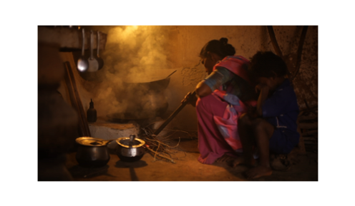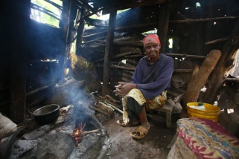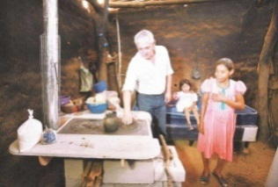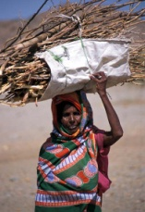

After convening the cookstove sector stakeholders (Step 2), work with this group to identify key barriers to the adoption of clean cooking solutions at scale, as well as potential intervention options and mechanisms for quickly and effectively taking action to address these barriers. This information can be put into a Country Action Plan, which other Alliance country partners have found useful to organize information about the specific needs of their own improved cookstove and fuels market development. Finally, with the Country Action Plan in place, the group can begin to develop an implementation plan for turning strategic plan into concrete action.

The Country Action Plan (CAP) will provide the context for why addressing the use of traditional cooking practices within a country is necessary, and identify key barriers to the adoption of clean cookstoves at scale, as well as the potential intervention options and mechanisms for quickly and effectively taking action in a specific country. The CAP should focus on the value-add role an alliance, as opposed to a patchwork of individual organizations, can potentially contribute, while recognizing that each Global Alliance partner has its own objectives, priorities and ways of working. In-country partners and stakeholders should develop a CAP that is specific to their nation’s cookstoves and fuels market, social customs, infrastructure, and challenges, that can eventually lead to the development of an implementation plan. The CAPs are also meant to serve as a means to make the case to governments and other partners that addressing the use of traditional cookstoves and fuels is essential, and can also be used as part of fundraising activities.

We have included a draft agenda for the meeting of stakeholders to begin discussions about the CAP as well as all of the tools needed to develop the CAP and the implementation plan. Filling out each piece of the templates along with the completed market assessment will provide much of the information needed to develop the plans needed to move from strategy to action as you catalyze a market.

**Tools and information included in this step:**

* Draft Agenda for Stakeholder Consultation and Strategic Planning Meeting
* Barriers and Intervention Options: Identification Template
* Country Action Plan Template
* Implementation Plan Template

## Draft Agenda for Stakeholder Consultation and Strategic Planning Meeting:

**Stakeholder Consultation and Strategic Planning Meeting:  
Moving Towards a Common Vision of Sector and Country Needs**

(City and Country)

(Date of Meeting)

(Specific Venue Location)

|  |  |
| --- | --- |
| **9:00-9:30am** | **Registration** |
| **9:30-9:50am** | **Opening remarks** |
| **9:50-10:15am** | **Participant Introductions** |
| **10:15-10:30am** | **Overview, Objectives and Desired Outcomes**   * Discuss current state of the sector * Identify barriers to improved cookstove and fuel adoption at scale * Identify potential intervention options for addressing barriers * Agree to way forward |
| **10:30-12:00pm** | **Presentation and Discussion of Market Assessment**   * Current State of the Sector * Consumer Research |
| **12:00-1:00pm** | **Lunch** |
| **1:00-2:30pm** | **Discussion of Barriers to Cookstove and Fuels Adoption at Scale**   * What are the barriers the sector faces? |
| **2:30-3:00pm** | **Coffee and tea break** |
| **3:00-4:30pm** | **Discussion of Potential Intervention Options**   * What interventions could be implemented to remove barriers? |
| **4:30-5:00pm** | **Agree to next steps for developing the market** |
| **5:00pm** | **Conclusion** |

## Barriers and Intervention Options Identification Template:

As a group, fill out this template as a means to identifying the barriers to achieving scale of improved cookstoves in your country, the means to overcome these barriers, and specifically how to achieve this desired outcome. This document will serve as the basis for the sector implementation plan, so it is advantageous to put in as much detail as possible.

|  |  |  |  |  |  |  |  |
| --- | --- | --- | --- | --- | --- | --- | --- |
| **Barriers** | **Intervention Options** | **Key Steps And Activities** | **Organizations Who Are Already Involved In This Area** | **Organizations Who Are Well Positioned To Become Involved** | **Timeline** | **Measuring Progress** | **Gender Implications** |
| Specific barriers preventing cookstoves from reaching scale | What is needed to overcome this barrier? | What does the sector need to do in order to achieve this intervention? | Which organizations are currently working in this area? | Which organizations should become involved in this area? | How long will  each step of this intervention take  to complete? | How will the sector measure progress towards achieving this outcome? | What are key gender issues and opportunities that should be considered? |
|  |  | 1)  2)  3)  4) |  |  | 1)  2)  3)  4) |  |  |
|  |  | 1)  2)  3)  4) |  |  | 1)  2)  3)  4) |  |  |
|  |  | 1)  2)  3)  4) |  |  | 1)  2)  3)  4) |  |  |

**Country Action Plan Template:**

Use the information collected during the market assessment and the stakeholder meeting to develop a CAP. A CAP defines what the cookstoves and fuels sector in a country can do to catalyze a thriving market for clean cooking solutions and how it may go about that process. The CAPs provide the national context for why addressing the use of traditional cookstoves and solid fuels is necessary, and then identify key barriers to the adoption of clean cookstoves and fuels at scale, the desired outcomes if these barriers are removed, and potential intervention options and mechanisms for quickly and effectively taking action in a specific country. CAPs focus on the value-add role an alliance (as opposed to a patchwork of individual organizations) can potentially contribute, while recognizing that each Alliance partner has its own objectives, priorities, and ways of working. In-country partners and stakeholders should develop a CAP that is specific to their nation’s cookstoves and fuels markets, social customs, infrastructure, and challenges, and will eventually be implemented. The CAPs are also meant to serve as a means to make the case to governments and other partners that addressing the use of traditional cookstoves is essential within this country, and can also be used as part of fundraising activities.

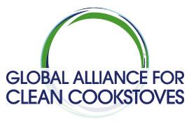

[Name of Country] CAP

Table of Contents

[Name of Country] Country Action Plan: Executive Summary 50

Actionable Intervention Options 51

Enhance Demand 51

Understanding, Motivating, and Meeting the Needs of the Consumer 51

Consumer Finance 51

Strengthen Supply 51

Innovative Distribution Methods 51

Access to Finance (social investment, working capital, carbon) 51

Entrepreneur Training and Capacity Building 52

Foster An Enabling Environment 52

Standards and Testing 52

Fuels and Technology 52

Monitoring and Evaluation 52

Building the Evidence Base (research on impacts and benefits) 52

Champion the Sector and Engage National Stakeholders 52

Targets/Key Performance Indicators (KPIs) for [name country] 53

Conclusions/Next Steps 54

Appendix 1: Macro Environment in [name country] 55

Appendix 2: State of the Sector in [name country] 55

Appendix 3: National Cookstove Alliance (if applicable) 57

Appendix 4: Acknowledgements 58

**[Name of Country] Country Action Plan: Executive Summary**

**Notes to help the writer complete this section:** This section summarizes the overall CAP. The reader should be able to read just the Executive Summary and get a grasp of the CAP’s purpose and the most important elements of its contents. Put another way, if you went through the near final version of the report with a highlighter pen and highlighted all the ‘key messages’, these should then appear in the Executive Summary.

**Actionable Intervention Options**

The five most urgent priority interventions, as identified by the coordinating partners and stakeholders, are underlined. All interventions are divided into three main categories of action:

* *Enhance demand*: understanding and motivating potential users, developing better technologies, and providing consumer finance;
* *Strengthen supply*: creating innovative distribution models to reach a wide variety of consumers, attracting more finance and investment, increasing access to carbon finance, enhancing market intelligence and creating inclusive value-chains;
* *Foster an enabling environment*: engaging national and local stakeholders, building the evidence base for the benefits of clean stoves and fuels, promoting international standards and rigorous testing protocols, enhancing monitoring and evaluation, and championing the sector.

***Enhance Demand***

### Understanding, motivating, and meeting the needs of the consumer

1. Identify intervention option #1 – make it specific and actionable

Necessary actions include:

* 1. List individual actions needed for above intervention option

1. Intervention option #2, etc.

### Consumer Finance

1. Identify intervention options and the accompanying necessary actions

***Strengthen Supply***

### Innovative Distribution Methods

1. Identify intervention options and the accompanying necessary actions

### Access to Finance (social investment, working capital, carbon)

1. Identify intervention options and the accompanying necessary actions

### Entrepreneur training and capacity building

1. Identify intervention options and the accompanying necessary actions

***Foster An Enabling Environment***

### 

### Standards and testing

1. Identify intervention options and the accompanying necessary actions

### Fuels and technology

1. Identify intervention options and the accompanying necessary actions

### Monitoring and evaluation

1. Identify intervention options and the accompanying necessary actions

### Building the evidence base (research on impacts and benefits)

1. Identify intervention options and the accompanying necessary actions

### Champion the sector and engage national stakeholders

1. Identify intervention options and the accompanying necessary actions

**Targets/Key Performance Indicators (KPIs)**

**Notes to help the writer complete this section**: Partners should outline concrete indicators and targets that are feasible in the short and long term. For example, with a key performance indicator of “fuel savings,” the short and long term targets may be a 30% reduction in fuel by 2015, a 30-60% reduction by 2017, and a 60% reduction in fuel by 2020. Or, for example, how many cookstoves will be sold in the country from 2012-2020.

# Conclusions/Next Steps

**Notes to help the writer complete this section:** This section should condense the “Next Steps” identified by the partners earlier in the document under each of the 10 major issues. This section should also provide final comments and conclusions to wrap up the document and make it cohesive.

**General note about the appendices:** The following appendices are optional, however they are recommended to give donors and interested parties a better picture of the state of the sector and the needs within the country. This information should have already been collected as part of the market assessment conducted in Step 1, so most of the information can just be repurposed here.

**Appendix 1: Macro Environment in [name of country]**

**Notes to help the writer complete this section:** This section is intended to be a broad overview of the country’s social demographics, politics, economy, gender attitudes, technology and infrastructure, and environment. Take care to identify the implications that each of these areas have on the cookstoves and fuels sector.

**Appendix 2: State of the Sector in [name of country]**

***Impact of Cookstove Smoke***

**Notes to help the writer complete this section:** This section should reflect the health, gender, livelihood and environmental impacts of cookstove smoke. Try to answer the following questions: How many people are adversely affected by cookstove smoke? What are the demographics? What types of health problems do they experience as a result of cookstove smoke? How prevalent are these health problems? How many deaths are attributed to illnesses caused by cookstove smoke?

***Consumer Information***

**Notes to help the writer complete this section:** This section should include information on the demographics and behaviors of the typical cookstove consumer and user. It should include answers to questions such as: What do consumers want from their cookstoves? What does the typical consumer look like – age, gender, location? What kind of cookstove does the typical consumer currently use? What kind of fuel? Where do they find or purchase their fuel? What kind of equipment does the typical consumer use when cooking – pots, utensils, stools or chairs, etc.? What kind of food do they cook? What are their purchasing preferences?

***Government Cookstove Involvement***

**Notes to help the writer complete this section:** This section is meant to give the reader a concise overview of past, present, and future government involvement in the cookstove sector. Try to answer the following questions: Which government ministries are involved in the cookstoves sector? What are they responsible for? Are there national standards in place for cookstoves? If so, what are they and who established them? What policies are already in place regarding cookstoves? Are there any policies that are in the planning stage? Where possible, it would be beneficial to consult with government representatives to complete this section.

***Mapping the Sector Players***

**Notes to help the writer complete this section:** This section is intended to reflect the various groups (governments, suppliers, NGOs, etc.) that are active in the cookstove sector in Bangladesh and their respective capabilities. Try to answer the following questions: Who is involved? What do they do? Do they do it well? Feel free to use the table below (from the Kenya CAP) as a template.

|  |  |  |  |  |  |  |  |  |  |  |  |  |  |  |  |  |  |
| --- | --- | --- | --- | --- | --- | --- | --- | --- | --- | --- | --- | --- | --- | --- | --- | --- | --- |
|  | Coordinate Program | Provide Funding | Coordinate Project (Region) | Centralize Act. (Mktg, Ops, Fin) | Educate on HAP | Raise product awareness | Run Promo Activities | Import & retail stoves | Design stoves | Test stoves | Train Stove Manufacturers | Supply Materials | Transport mat. to Manufacturer | Make stoves | Transport stove to customer | Sell and install Stoves | Maintain Stoves |
| Multilaterals & Donors - EU, DGIS, USAID, DFID |  |  |  |  |  |  |  |  |  |  |  |  |  |  |  |  |  |
| Government - Ministry of Energy |  |  |  |  |  |  |  |  |  |  |  |  |  |  |  |  |  |
| Banks & Investment Funds |  |  |  |  |  |  |  |  |  |  |  |  |  |  |  |  |  |
| Micro Finance Institutions – SACCOS |  |  |  |  |  |  |  |  |  |  |  |  |  |  |  |  |  |
| INGOs and Local NGOs - GIZ, Practical Action, etc. |  |  |  |  |  |  |  |  |  |  |  |  |  |  |  |  |  |
| Gas companies - LPG Fuel Providers |  |  |  |  |  |  |  |  |  |  |  |  |  |  |  |  |  |
| Local manufacturers & suppliers |  |  |  |  |  |  |  |  |  |  |  |  |  |  |  |  |  |
| Low Quality Stoves Suppliers - jua kali |  |  |  |  |  |  |  |  |  |  |  |  |  |  |  |  |  |
| Local Quality Stove Suppliers |  |  |  |  |  |  |  |  |  |  |  |  |  |  |  |  |  |
| International Manufacturers |  |  |  |  |  |  |  |  |  |  |  |  |  |  |  |  |  |
| Local Entrepreneurs - Import, Retail, Distribution |  |  |  |  |  |  |  |  |  |  |  |  |  |  |  |  |  |

**Basic capability**

**Partial capability**

**No capability**

**Full capability**

**Key:**

**Common Cooking**

**Notes to help the writer complete this section:** This section should reflect all of the common cookstove models that are widely available and applicable to the country’s market. Feel free to use the table template below (from the Kenya CAP). This section should be about two pages in length.

**Technologies:­­**

|  |  |  |  |  |
| --- | --- | --- | --- | --- |
|  | **Description: C:\Users\GVEP\AppData\Local\Microsoft\Windows\Temporary Internet Files\Content.Word\SCODE 119.jpg**  **Kenyan**  **Ceramic Jiko** | **Description: C:\Users\GVEP\AppData\Local\Microsoft\Windows\Temporary Internet Files\Content.Word\P8251101.jpg**  **Uhai**  **Stove** | **Multi-purpose**  **stove** | **Description: C:\Users\abcdef_123\Pictures\My Pictures\Kenya stoves - new collection\Annes Visit 006.JPG**  **Upesi  (Portable and Liner)** |
| **Cost Range** | $4-$10 | $10 - $18 | $9 | $3-4 (Liner fixed)  $10 (Portable) |
| **Thermal**  **Efficiency** | 30-40% | 36% | 20% (Wood), 30% (Charcoal) | 25-30% (Both)  Firewood stove |
| **Manufacturer** | Various | Keyo Pottery Enterprise, various | Various | Keyo Pottery Enterprises Kisumu and various potters in Western Kenya |
| **Key Features** | Ceramic liner with metal cladding. Production has been sustained on commercial basis | Improvement on the KCJ with clay rim to retain and direct heat. | Ceramic liner and metal cladding with removable charcoal grate so it can be used with both wood and charcoal | – Liner is permanently installed in kitchens, (Liner)  - Upesi liner with metal cladding for portability |
| **Production**  **Capacity** | Demand driven. Collectively large but individual producers make a few hundred a month. Liner producers may have higher capacity. | Not extensively produced- demand driven. Most production in the hundreds per month. | Not extensively produced- demand driven. Most production in the hundreds per month. | Liner-Demand driven,  liners are produced by individuals and groups and usually installed by trained installers in individual kitchens. Estimated over 1.2 million have been produced  Portable- Extensively in western Kenya, Varies amongst regions, both in terms of quality and access.  Estimated over 500,000 produced. Most producers can make several hundred per month. |
| **Distribution**  **Channels** | Complete stoves sold through middlemen, retailers, markets & small vendors. | Sold through retailers, middlemen and markets. | Sold through retailers, middlemen and markets. | -Liner sold and installed through installers at the individual level on a commission basis  Portable- Complete stoves sold through retailers, middlemen and markets and small venders. |

**Appendix 3: National Cookstove Alliance (if applicable)**

**Notes to help the writer complete this section:** This section should be completed only if a national organizational structure exists, or will soon exist. The Global Alliance Secretariat hopes either existing or newly-formed organizations will represent the cookstove sector in each country. For example, a Nigeria Alliance for Clean Cookstoves launched in March 2012 and has been actively working toward its goal of 10 million Nigerian homes adopting clean cooking solutions by 2020. In countries where such coordinating bodies already exist, the Alliance Secretariat will look to these groups to implement large parts of the Country Action Plan, which notes that direct Global Alliance support for these entities is dependent upon them fulfilling certain criteria. This section should outline the structure of the national coordinating body, as well as their planned involvement in the implementation of the CAP.  
  
  
  
**Appendix 4: Acknowledgements**

**Notes to help the writer complete this section:** List all partners and organizations that contributed to the development of the CAP.

**Implementation Plan Template:**

Following the completion of the Country Action Plan, use the implementation plan template to go from the strategic planning phase to action. The implementation plan template will help you organize the intervention options within the CAP into an action-oriented document with specific steps to achieve the desired intervention option, anticipated risks or challenges and plans to overcome them, a timeline for each step and the overall intervention, deliverables for each step to ensure accountability, a budget and the anticipated or realized source of funding, the partners who will be involved, roles and responsibilities of the partners, and the key performance indicators for evaluation.

**Implementation Plan**

An implementation plan is essential to take well intentioned plans to action. Below is a template that can be used to determine each of the steps needed to overcome the barriers currently impeding the improved cookstoves and fuels markets. We have put in one example to show how the template might be utilized, with space at the bottom for you to begin filling this out for your country’s implementation plan.

**Template:**

| Objective | Anticipated Risks Or Challenges And Plans To Overcome Them | Steps To Achieve Action | Timeline | Deliverables | Budget | Funding Source Or Fund-Raising Plan | Partners To Be Involved, Responsibilities Of Partners | Key Performance Indicators And Plan For Evaluation |
| --- | --- | --- | --- | --- | --- | --- | --- | --- |
| Provide initial support to a representative body that will coordinate stakeholders, raise the profile of improved cookstoves, and provide bargaining power for the industry with regard to government policy. | Possible use of funds inconsistent with overall body objectives.   *Representative body, regardless of leadership, must open separate bank account and have agreed to structure among membership for decisions regarding funds.  There must additionally be an agreed to reporting structure of how funds are used back to the Alliance.* | Identify appropriate representative body through phone calls and reaching out to stakeholder for suggestions and identify point of contact at representative body to conduct all work.  Discuss financial needs of representative body with point of contact.  Develop grant based off of above identified needs and grant reporting structure in alignment with Alliance reporting mandates and national alliance reporting mandates.  Award initial grant support to representative body.  Receive reports from representative body quarterly. | Representative body to send proposal for initial plan and needs - January 1, 2013   Representative body to be officially registered - January 15, 2013 and open bank account   Regional Market Manager to coordinate and assist on grant management and implementation | Notes from discussions with stakeholders  Budget given to the Alliance by the representative body showing where funds are needed, where they will be used, and how they will be supplemented if necessary.  Grant reporting structures sent to the representative body.  Grant awarded.  Grant reports showing progress of representative body quarterly. | Limited support not to exceed: $15,000   Staff time: $10,000   Website: $1,000   Meetings: $2,000   Marketing materials: $1,000   Administrative costs: $1,000 |  | Partners will be determined through strategic process.   Partners will lead the development and work of the representative body. | Representative body is recognized as a neutral, but active body in representing sector needs able to engage with government and coordinate stakeholders - other deliverables to determine within context of grant proposal from representative body in January. |

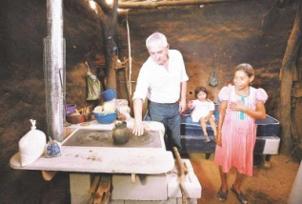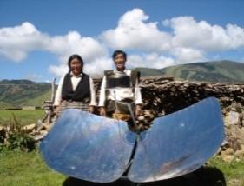

With the knowledge of what must be done to catalyze the improved cookstoves and fuels sector in the CAP (Step 3) you can now begin to develop an advocacy strategy and communications plan with which to approach the government, potential donor organizations, and potential investors.

The CAP will provide the context for why addressing the use of traditional cookstoves and fuels within a country is necessary, and identifies key barriers to the adoption of clean cooking solutions at scale, as well as the potential intervention options and mechanisms for quickly and effectively taking action in a specific country. The CAPs are also meant to serve as a means to make the case to governments and other partners that addressing the use of traditional cookstoves and fuels is essential, and can also be used as part of fundraising activities.

This step includes meeting with policy makers within the government and planning to ensure that these meetings will be as effective and impactful as possible. In preparation for meeting with the government, the stakeholder group should work to align cookstoves interventions with national priorities surrounding health outcomes, environmental protection, women’s empowerment, and overall development objectives. Most governments have national priorities or goals that their policies work to achieve, for example, many governments prioritize the empowerment of women and seek to achieve this broad goal through a number of policy interventions. This is especially true for countries that have committed to working towards the Millennium Development Goals, for which there are clear indicators of success towards development and for which there is a progress report developed. The adoption of improved cookstoves and fuels can help a country meet goals in several areas, including: economic growth, improved employment rates, decreased child mortality, improved health outcomes, empowerment of women, climate mitigation, and environmental protection.

The aforementioned national priorities should be mapped as part of the market assessment in Step 1. Next, a comprehensive document stating how clean cooking solutions could play a role in advancing the identified national priorities should be established so that the government officials can clearly see how prioritizing cooking would be advantageous for both the government and the improved cookstoves market. Finally, a communications and advocacy plan should be developed to help communicate those messages to the government, potential funding sources, and to the broader public.

**Tools and information included in this step:**

* National Priority Mapping Template
* Ideas for Ways to Engage the Government
* Communications Plan Template
* Country factsheets
* Overview of Issue One Pager
* Health Impact One Pager
* Empowering Women One Pager
* Environmental One Pager

**National Priority**

Use the information collected in the market assessment as well as the template below to organize the information about which areas the government has stated are a national priority, how addressing the use of traditional cookstoves could contribute to this goal, and which ministry should be approached about this.

**Mapping Template:­­**

­

|  |  |  |  |  |
| --- | --- | --- | --- | --- |
| National Priority Areas | Economic | Health | Women | Environment |
| **­­­** |  |  |  |  |
|  |  |  |  |
|  |  |  |  |
|  |  |  |  |
|  |  |  |  |
|  |  |  |  |
| **How Cookstoves Could Contribute To Progress In This Area:** |  |  |  |  |
| **Lead Government Ministry To Approach:** |  |  |  |  |

**Ideas for Ways to Engage the Government:**

Through meetings with government representatives worldwide, the Global Alliance has learned several effective ways of engaging or interesting governments in our sector, as well as several ways that government engagement can be beneficial to the adoption of clean cooking solutions at scale:

* Develop a white paper to show the government how inefficient and dangerous cooking practices affect people in your country and present policy options for catalyzing a market.
  + Possible policy suggestions:
    - Reduce tariffs to allow imported improved cooking technologies to be sold at lower prices, increasing the number of clean and efficient products available in the market and allowing for greater consumer product choice;
    - Establish tax incentives to assist existing improved cookstove and fuel businesses and encourage others to become involved in the sector;
    - Commit funding to research and development of improved cooking technologies that meet the needs of local populations; and
    - Reduce interest rate on loans at the household level and at the enterprise level to scale up adoption and production.
* Utilize national infrastructure and messaging outlets such as billboards and radio time to run a large scale awareness raising campaign to inform the population about household air pollution and other consequences of cooking with traditional cookstoves and fuels.
* Include improved cookstoves and fuels in school curriculums in order to teach school age children about both problems and solutions.
* Incorporate information about improved cookstoves and fuels into information handed out at health clinics and in pre-natal care programs.
* Invite government representatives to join cookstoves stakeholder meetings to stay well informed about recent activity in the sector and the sector’s needs.

**Communications Plan Template:**

A communications plan is essential to help your organization fulfill its mission and reach its goal. Communications plans can come in many forms: a strategic plan for your entire organization; an annual plan; or a communications plan around a specific event or date (i.e., the rollout of a report, or a major conference). The following areas are those that are essential to think through and develop in order to ensure a well thought through and strategic communications plan for an organization or representative body.

1. Objective of your Organization and its Communications Goals
   1. State your organization’s goal and mission, and how your communications plan will help achieve them.
2. Top Messages
   1. Message development is important for consistency and branding. What are the top messages you want your leadership, spokespeople, and partners to use, reiterate, and reinforce when speaking publicly?
3. Targeting Different Audiences
   1. What stakeholders do you want to speak to? Media? Donors? Implementers?
   2. Ensure that each audience has messaging that is targeted to their interests and individual goals.
4. Specific Tactics
   1. Press Releases
   2. Op-Eds
   3. Media Interviews
   4. Events
   5. Publications
   6. Webinars
   7. Enlisting support of celebrities or important individuals
5. Metrics for Success
   1. How will you measure your communications success? Number of press hits? Increase in social media followers and engagement? Website visits? Money raised?
6. Key Dates
   1. Know ahead of time the events you want to attend, or that you want to create, or the key international dates of relevance to your work (for example: World Pneumonia Day, Earth Day, International Women’s Day)

**Awareness Raising Factsheets:**

The following factsheets include information that can be made specific to cooking in each partner country and can be used to help raise awareness among the general population or for targeted outreach to government representatives or potential donors. The factsheets provided here include a general overview of the issue, as well as factsheets specific to the impact that traditional cookstoves have on the environment, women’s empowerment, and health in each partner country.

The factsheets currently have placeholders for photos on them so that you can add photos of your own work and of the in-country context to make them even more compelling. Photos make factsheets more interesting for all audiences, and we recommend that you add photos specific to the topic areas (for example, photos of women in the women’s empowerment factsheet) to make the factsheet and its messages even more memorable.

As an example of the country-specific factsheets as part of this generic partner country toolkit, we have included awareness raising factsheets for Burkina Faso.

## 

**By the Numbers:   
Burkina Faso**

**95%**  
percentage of population that relies on solid fuels

**12.8 million**  
people affected

**2.4 million**   
households affected

**16,086**  
deaths per year from exposure to cookstove smoke

**11,824**child deaths per year from exposure to cookstove smoke

## Cookstoves in Burkina Faso

## 

## *The Issue*

Exposure to smoke from traditional cookstoves and open fires - the primary means of cooking for more than three billion people in the developing world - causes nearly 4 million premature deaths annually, including 16,086 deaths in Burkina Faso every year.

Household air pollution (HAP) contributes to a range of chronic illnesses and acute health impacts such as lower respiratory infections (ALRI), chronic obstructive pulmonary disease (COPD), adverse pregnancy outcomes, emphysema, cataracts, lung cancer, bronchitis, ischemic heart disease, cerebrovascular disease, and low birth weight. Women and young children are the most affected by the health problems associated with exposure to HAP, with many women and children in Burkina Faso dying every year as a result of acute lower respiratory infections, including pneumonia, caused by the use of solid fuels.

Reliance on biomass for cooking increases pressures on local natural resources and forces women and children to spend many hours each week collecting wood. In Burkina Faso, 88% of households rely on fuelwood for their household cooking needs, contributing to environmental deforestation and desertification. Inefficient cookstoves also contribute to climate change through emissions of greenhouse gases such as carbon dioxide and aerosols such as black carbon.

***The Solution***

The use of clean, safe, efficient, and affordable cookstoves can dramatically reduce fuel consumption and exposure to harmful cookstove smoke, can provide myriad economic opportunities for the people of Burkina Faso, and can help reduce deforestation. More efficient stoves also reduce the time people need to spend collecting fuel, allowing greater time to devote to income generating activities or schoolwork.

In Burkina Faso, the economic opportunities brought by clean cooking solutions could be transformational. The entire clean cookstove supply-chain could be a source of economic opportunity and job creation at the local level. Whether cookstoves are mass-production in a central location or produced locally, local business partners are needed for distribution, sales, and service of stoves, as well as supply of processed fuels where appropriate. A thriving global industry for clean cooking solutions will provide these benefits on a sustainable basis, providing jobs to many thousands of individuals.

**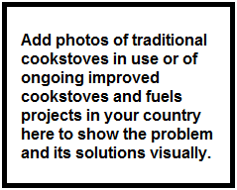**

**By the Numbers:   
Burkina Faso**

**95%**  
percentage using wood and charcoal for cooking

**0.11**  
carbon dioxide emissions (metric tons per capita)

**9689.73**  
fuelwood consumption per thousand households (m³)

**1.01%**  
average annual rate of deforestation (2000-2010)

**20.6%**  
forested area

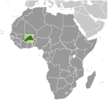**Cookstoves and the Environment  
in Burkina Faso**

***Inefficient Cooking Contributes to Environmental Degradation***

More than 3 billion people globally rely on open fires or traditional cookstoves to cook every day. These cookstoves are often fueled by solid fuels such as biomass or coal which, in the case of biomass, must often be gathered from their nearby environment. The production and use of biomass fuel for cooking lead to the consumption of roughly one billion tons of wood fuel every year. At a local level, this contributes to deforestation and broader environmental degradation from weakened soil which causes erosion and mudslides, and destroys valuable agricultural land. At a global level, the inefficient burning of solid biomass releases a toxic mix of health damaging pollutants that contributes to global climate change. Some of these pollutants, such as black carbon and methane, have significant consequences for climate change despite their short life spans. Black carbon is estimated to contribute the equivalent of up to half of CO2 warming globally, with coal production and residential solid fuel burning for cooking contributing a quarter of all global black carbon emissions, while methane emissions are the second largest cause of climate change after carbon dioxide.

***Clean Cookstoves and Fuels Can Help Contribute to Environmental Protection***

Clean cookstoves and fuels can lead to a more sustainable and cleaner environment. If appropriately designed and disseminated, clean cookstoves can reduce a large share of emissions from cooking with biomass. Researchers have estimated that potential greenhouse gas emission reductions could exceed 1 billion tons of carbon dioxide equivalent (CO2). These reductions also bring other benefits, such as reduced indoor and outdoor pollution, less pressure on forests, and economic and time savings due to the reduced need to search for or purchase costly fuels. Since they have short life spans – a few days for black carbon, a decade for methane – reducing these gases would have a rapid positive effect on the climate.



It is estimated that universal adoption of advanced biomass cookstoves could have an impact equivalent to reducing carbon dioxide emissions by 25–50 percent. In a series of recent reports, the United Nations Environment Programme emphasized the importance of introducing clean-burning biomass cookstoves and substituting traditional cookstoves with those that use modern fuels in order to mitigate climate change and improve air quality.



**Cookstoves and Women’s Empowerment  
in Burkina Faso**

**By the Numbers:   
Burkina Faso**

**80%**   
female labor force participation rate

**18%**  
share of women employed in non-agricultural sectors

**42%**  
female primary school completion rate

**33%**  
female literacy rate (age 15-24)

***Women are Disproportionately Affected by Household Air Pollution***

Each day more than 3 billion people rely on solid fuels to cook their food, using traditional cookstoves or open fires in households with little or no ventilation. Exposure to smoke from these polluting and inefficient forms of cooking kills 4 million people annually, with millions more suffering from cancer, pneumonia, heart and lung diseases, blindness, and burns. The negative effects of traditional cooking on gender equity are clear as cooking is traditionally a female gender role across much of the world. Given their proximity to cooking fires, women and girls bear disproportionate risks from the negative household air pollution health outcomes. In addition, women and girls are also typically responsible for gathering fuel to cook the family meal, facing increased risk of gender-based violence as they leave the safety of their communities during lengthy fuel foraging trips, particularly in conflict areas and from refugee camps. Furthermore, time spent collecting fuel is time not spent on income-generation, education, or other activities. Cooking has become one of the most dangerous daily activities for women in the developing world, however, while women bear a disproportionate burden, they’re also critical to the solutions.

***Working Toward a Solution***

Clean cooking solutions can be a powerful tool for women’s empowerment. The clean cookstove value chain offers new pathways for women’s economic opportunities as women can participate in, own businesses around, and earn income from product design, engineering, manufacturing, maintenance, marketing, distribution, sales and related enterprise that involve cooking, such as restaurants and street food vendors. Women and girls use 90 percent of their income in ways that benefit their families and communities, compared to 30-40% for men, and therefore their significant capacity to reduce global poverty is chief among the aggregate economic benefits associated with the use of clean cookstoves. As primary users, women’s needs and preferences are also central to successful cookstove design and adoption. In addition, women play a substantial role in increasing awareness and generating demand among their networks – awareness about the dangers of household air pollution and the demand for new technologies to mitigate them. Women’s networks and relationships within and across communities can be instrumental for speeding adoption and widespread use.



**By the Numbers:   
Burkina Faso**

**12.8 million**  
people affected

**2.4 million**   
households affected

**16,086**  
deaths per year from exposure to cookstove smoke

**11,824**child deaths per year from exposure to cookstove

**21%**deaths due to non-communicable diseases

**Cookstoves and Health  
in Burkina Faso**

***The Impact of Cookstoves on Health***

Mortality from diseases linked to household air pollution already equals that of better known crises like malaria, tuberculosis, and HIV/AIDS **combined**, with exposure to smoke from traditional cookstoves and open fires causing 4 million premature deaths annually. Cookstove smoke contributes to a range of chronic illnesses and acute health impacts such as chronic obstructive pulmonary disease, emphysema, lung cancer, cataracts, bronchitis, cerebrovascular disease, and ischemic heart disease. Household air pollution (HAP) is the most widespread risk factor for non-communicable diseases (NCDs) in the developing world, impacting nearly 100 percent of the poorest 3 billion people. However, despite the fact that millions are moving out of poverty, continued population growth results in more people being exposed to HAP today than ever before. Household air pollution is the leading risk factor for lung cancer and chronic lung disease among non-smoking women in developing countries, is a major risk factor for acute lower respiratory infections, and increases the risk of adverse pregnancy outcomes and delivering low birth-weight babies. Eye disease, chronic eye irritation, and headaches have been widely reported by women cooking in solid fuel using households. In addition, the health effects of gender-based violence experienced when women and girls travel distances to collect fuelwood cannot be ignored.

Effectively addressing these health problems requires moving beyond a focus on treatment toward preventive interventions that minimize environmental and behavioral risk factors. These diseases also affect economic development by overloading healthcare systems and reducing productivity of the global workforce and their families due to long term treatments necessary.

***Clean Cooking Solutions Can Prevent Negative Health Impacts***

Clean cookstoves and fuels are evidence-based, cost-effective methods to prevent non-communicable diseases and other major side effects of traditional cooking, including blindness, burns, and other injuries on global to local levels. Four million deaths each year, many of them children, can be prevented by preventing household air pollution through the widespread adoption of cleaner, safer cookstoves.

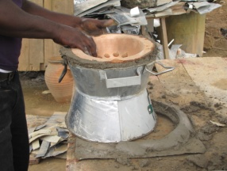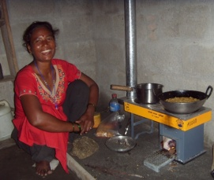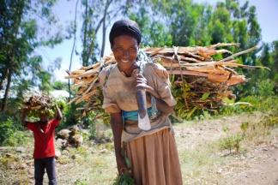

The cookstoves design and manufacturing communities are continually improving the performance of their technologies to make them cleaner, safer, and more efficient. However, the previous lack of international standards related to cookstove performance and quality has made it challenging for manufacturers, distributors, investors, and users to rate cookstoves for factors such as safety, durability, efficiency, and emissions. Having a set of standards that clearly defines technology performance levels can benefit all stakeholder groups: it benefits users by providing information to make informed choices and purchases; designers and manufacturers by affirming their product quality and driving innovation; policy makers, donors, investors, and program managers by establishing a credible basis for comparing stove performance and safety; and it provides all stakeholders with a common terminology for communicating, understanding, and improving stove performance and adoption. As a formal, consensus-based standards process can take several years to finalize, the Alliance has worked through an inclusive, international process to form interim guidelines and to develop interim standardized reporting structures for the cookstoves and fuels communities to use prior to a formal standard. In parallel, the Alliance will support the formal international standards process, which will build from the lessons learned from the interim guidelines.

As international standards are being developed, it is necessary for those in the cookstoves and fuels communities to test new and existing technologies to ensure that they are achieving the emissions reductions and efficiency gains that they aspire to. Across the clean cooking sector, there has been widespread consensus on the need for a comprehensive and transparent understanding of how current technologies and fuels perform in the laboratory and the field. The Alliance has compiled a detailed inventory of cookstove and fuel performance, including emissions, indoor air pollution, efficiency, fuel use, and other metrics from a range of laboratory- and field-based protocols. In addition to existing data, the Alliance has also been working together with Regional Testing and Knowledge Centers around the world to keep the inventory standardized and up-to-date with new testing results. A detailed report of the inventory is available in the resources section of the Alliance’s website and an online searchable version of the inventory that will allow stakeholders to look up the testing results of specific technologies is currently under development.

This section of the toolkit will provide you with information about the International Organization for Standardization member information for each partner country, information about the standardization process, a list of testing centers where you can get technologies tested, as well as information about what specific reporting requirements exist for the International Workshop Agreement tiers of performance.

The Alliance has also been actively supporting the development of laboratory and field testing capacity globally, in all partner countries. The Alliance is working to build a consortium of centers that can catalyze regional activities and support regional organizations. The centers will also work together as a consortium to standardize results and establish best practices and common data formats to share and integrate testing results.

**Tools and information included in this step:**

* International Organization for Standardization member information
* List of global testing centers
* International Workshop Agreement IWA 10 ([attached](https://unfoundation.box.com/s/6nqfvxochxr7d61jwme0))
* Interim Reporting Requirements for IWA tiers of performance ([attached](https://unfoundation.box.com/s/6nqfvxochxr7d61jwme0))
* Cookstove performance inventory (currently in development)

## International Organization for Standardization Member Information:

The first step in adopting international standards is to contact your national standards body. As a corresponding member of the International Organization for Standardization (ISO), the body should be encouraged to follow the development of the cookstove standard process and to communicate with the Global Alliance directly with their feedback so that the Global Alliance can subsequently advocate on their behalf. Below is the information for the standards body in your country, and we have [attached](https://unfoundation.box.com/s/6nqfvxochxr7d61jwme0) to this toolkit the International Workshop Agreement information for you to provide to the standards body as background.

***ISO members in Alliance partner countries:***

**Afghanistan**

Afghanistan National Standards Authority  
Kabul Jalababad Road  
Industrial Parks Area  
AF- Kabul

Postal Address:

Central Post Office  
P.O. Box 5172$Central Post Office  
AF- Kabul

Tel: +93 202320117  
E-mail: [icd@ansa.gov.af](mailto:icd@ansa.gov.af)   
Web: [www.ansa.gov.af](http://www.ansa.gov.af/" \t "_blank)

**Burkina Faso**

Direction de la Normalisation et de la Promotion de la Qualité  
Immeuble APEX-Burkina (ex-ONAC)  
30, Avenue de l'UEMOA  
BP : 389  
**BF- Ouagadougou 01**

Tel: +226 50 31 13 00  
Fax: +226 50 31 13 00  
E-mail: [secretariat.onac@gmail.com](mailto:secretariat.onac@gmail.com)

**Cambodia**

nstitute of Standards of Cambodia  
Ministry of Industry, Mines and Energy  
#538 National Route N° 2  
Chak Angre-Leu Quarter, Meanchey District  
**KH-Phnom Penh**

Tel: +855 12 818908  
Fax: +855 23 425052  
E-mail: [discinfo@camnet.com.kh](mailto:discinfo@camnet.com.kh)   
Web: [www.isc.gov.kh](http://www.isc.gov.kh/" \t "_blank)

**Colombia**

Instituto Colombiano de Normas Técnicas y Certificación  
Carrera 37 52-95, Edificio ICONTEC  
P.O. Box 14237  
**CO-Bogotá, D.C.**

Tel: +57 1 607 88 88  
Fax: +57 1 222 14 35  
E-mail: [direccion@icontec.org](mailto:direccion@icontec.org)   
Web: [www.icontec.org](http://www.icontec.org/" \t "_blank)

**El Salvador**

Organismo Salvadoreño de Normalización  
1° Calle Poniente y final 41 av. Norte,  
#18. Col Flor Blanca  
**SV-San Salvador**  
  
Tel: +503 2247 5321  
Fax: +503 2225 6255  
E-mail: [ycolindres@osn.gob.sv](mailto:ycolindres@osn.gob.sv)   
Web: [www.infoq.org.sv](http://www.infoq.org.sv/" \t "_blank)

**Ethiopia**

Ethiopian Standards Agency  
P.O. Box 2310  
**ET-Addis Ababa**

Tel: +251 11 6 46 01 11  
Fax: +251 11 6 46 08 80  
E-mail: [info@ethiostandards.org](mailto:info@ethiostandards.org)   
Web: [www.ethiostandards.org](http://www.ethiostandards.org/" \t "_blank)

**Guatemala**

Comisión Guatemalteca de Normas  
Calzada Atanasio Tzul 27-32 zona 12  
**GT-Guatemala C.A. 010012**

Tel: +502 2247 2654  
Fax: +502 2247 2687  
E-mail: [info-coguanor@mineco.gob.gt](mailto:info-coguanor@mineco.gob.gt)   
Web: [www.coguanor.gob.gt](http://www.coguanor.gob.gt/" \t "_blank)

**Laos**

Department of Intellectual Property, Standardization and Metrology  
National Authority for Science and Technology (NAST)  
Nahaidiou Rd  
P.O. Box 2279  
**LA- Vientiane**  
  
Tel: + 856 21 264 202  
Fax: + 856 21 213 472  
E-mail: [nsisomphet@yahoo.com](mailto:nsisomphet@yahoo.com)

**Lesotho**

Standards and Quality Assurance Department  
Ministry of Trade and Industry, Cooperatives and Marketing  
P.O. Box 747  
**LS-Maseru 100**

Tel: +266 22 31 74 54  
Fax: +266 22 31 03 26  
E-mail: [lessqa@leo.co.ls](mailto:lessqa@leo.co.ls)

**Malawi**

Malawi Bureau of Standards  
Moirs Road  
**MW-Blantyre**

### Postal Address:

P.O. Box 946  
P.O. Box 946  
**MW-Blantyre**

Tel: +265 1 870 488  
Fax: +265 1 870 756  
E-mail: [mbs@mbsmw.org](mailto:mbs@mbsmw.org)   
Web: [www.mbsmw.org](http://www.mbsmw.org/" \t "_blank)

**Mexico**

Dirección General de Normas  
Ave. Puente de Tecamachalco N° 6  
Col. Lomas de Tecamachalco  
Sección Fuentes  
**MX-C.P. 53950 Naucalpan de Juárez, Edo. de México**

Tel: +52 55 57 29 94 80  
Fax: +52 55 55 20 97 15  
E-mail: [iso-mex@economia.gob.mx](mailto:iso-mex@economia.gob.mx)   
Web: [www.economia.gob.mx](http://www.economia.gob.mx/" \t "_blank)

**Mongolia**

Mongolian Agency for Standardization and Metrology  
Bayanzurkh District  
Peace Avenue-46A  
P.O. Box 48  
**MN-13343 Ulaanbaatar**

Tel: +976 11 453574  
Fax: +976 11 458032  
E-mail: [masm@mongol.net](mailto:masm@mongol.net)   
Web: [www.masm.gov.mn](http://www.masm.gov.mn/" \t "_blank)

**Nepal**

Nepal Bureau of Standards and Metrology  
P.O. Box 985  
Balaju  
**NP-Kathmandu**

Tel: +977 1 4356810  
Fax: +977 1 4350689  
E-mail: [nbsm@nbsm.gov.np](mailto:nbsm@nbsm.gov.np)   
Web: [www.nepalstandards.gov.np](http://www.nepalstandards.gov.np/" \t "_blank)

**Peru**

Instituto Nacional de Defensa de la Competencia y de la Protección de la Propiedad Intelectual  
Calle La Prosa 104  
San Borja  
**PE-Lima 41**  
  
Tel: +51 1 224 78 00  
Fax: +51 1 224 78 00  
E-mail: [standards@indecopi.gob.pe](mailto:standards@indecopi.gob.pe)   
Web: [www.indecopi.gob.pe/](http://www.indecopi.gob.pe/" \t "_blank)

**Rwanda**

Rwanda Bureau of Standards  
P.O. Box 7099  
**RW- Kigali**

Tel: +250 252 582945  
Fax: +250 252 583305  
E-mail: [info@rbs.org.rw](mailto:info@rbs.org.rw)   
Web: [www.rwanda-standards.org](http://www.rwanda-standards.org/" \t "_blank)

**South Africa**

South African Bureau of Standards  
1 Dr Lategan Rd, Groenkloof  
Private Bag X191  
**ZA-Pretoria 0001**  
  
Tel: +27 12 428 79 11  
Fax: +27 12 344 15 68  
E-mail: [wto@sabs.co.za](mailto:wto@sabs.co.za)   
Web: [www.sabs.co.za/](http://www.sabs.co.za/" \t "_blank)

**Tanzania**

Tanzania Bureau of Standards  
Ubungo Area  
Junction of Morogoro/Sam Nujoma Roads  
**TZ-Dar es Salaam**

### Postal Address:

P.O. Box 9524  
P.O. Box 9524  
**TZ-Dar es Salaam**

Tel: +255 22 2450 298  
Fax: +255 22 2450 959  
E-mail: [info@tbs.go.tz](mailto:info@tbs.go.tz)   
Web: [www.tbs.go.tz](http://www.tbs.go.tz/" \t "_blank)

**Vietnam**

Directorate for Standards, Metrology and Quality  
8, Hoang Quoc Viet Road  
**VN-Hanoi**

Tel: +84 4 3791 16 30  
Fax: +84 4 3791 15 95  
E-mail: [htqt@tcvn.gov.vn](mailto:htqt@tcvn.gov.vn)   
Web: [www.tcvn.gov.vn](http://www.tcvn.gov.vn/" \t "_blank)

**List of Global**

This list includes examples of organizations that are focused on a cookstoves and fuels testing and/or design. To suggest additional organizations to include, please contact Ranyee Chiang, Senior Technical Manager for Standards and Testing with the Global Alliance for Clean Cookstoves (rchiang@cleancookstoves.org).

**Testing Centers:**

|  |  |  |  |  |
| --- | --- | --- | --- | --- |
| **Organization** | | **Location** | **Point Of Contact** | **E-Mail Address** |
| Stove Testing Center | | La Paz, Bolivia | Marcelo Gorrity | mgorritty@gmail.com |
| GERES Biomass Energy Lab | Phnom Penh, Cambodia | David Beritault | d.beritault@geres.eu |
| Beijing University of Chemical Technology (BUCT) | | Beijing, China | Guangqing Liu | guangqing.liu@gmail.com |
| China Agricultural University (CAU) | | Beijing, China | Yuguang Zhou | zhouyg@cau.edu.cn |
| GIZ Burkina Faso | | Burkina Faso | Alemayehu Zeleke | alemayehu.zeleke@giz.de |
| Council for Scientific and Industrial Research (CSIR) | | Accra, Ghana | Gabriel Nii Laryea | gabniilar@yahoo.com |
| Improved Cooking Technology Program | | Port au Prince, Haiti | Jean Robert Altidor | csaaltidor@gmail.com |
| Zamorano University Improved Stove Certification Center | | Tegucigalpa, Honduras | Timothy Longwell | tlongwell@zamorano.edu |
| Indian Institute of Technology-Delhi (IIT-Delhi) | | New Delhi, India | Rajendra Prasad | rprasadiitd@gmail.com |
| Prakti Design Lab | | Pondicherry, India | Mouhsine Serrar | mouhsine@praktidesign.com |
| The Energy and Resources Institute (TERI) | | New Delhi, India | Perumal Raman | praman@teri.res.in |
| Asia Regional Cookstove Program (ARECOP) | | Yogyakarta, Indonesia | Christina Aristanti Tjondroputro | christina@arecop.org |
| Kenya Industrial Research and Development Institute (KIRDI) Stove Testing Centre | | Nairobi, Kenya | Nathan Bogonko | nbogonko@gmail.com |
| Universidad Nacional Autónoma de México (UNAM) | | Mexico City, Mexico | Victor Berrueta | vberrueta@gmail.com |
| GIZ /EnDev Mozambique | | Mozambique | Rosario Loayza Cortez | rosario.loayza@giz.de |
| Centre for Rural Technology, Nepal (CRT/N) | | Kathmandu, Nepal | Hari Gopal Gorkhali | gorkhali@crtnepal.org |
| Regional Stoves Development and Testing Center at the International Centre for Energy, Environment and Development (ICEED) | | Afikpo, Nigeria | Joseph Dioha | diohaij@yahoo.com |
| Laboratorio de Certificación de Cocinas Mejoradas (SENCICO) | | Lima, Peru | Gabriela Esparza Requejo | gesparza@sencico.gob.pe |
| The Centre for Study and Research on Renewable Energy (CERER) | | Dakar, Senegal | Issakha Youm | iyoum2@yahoo.fr |
| Sustainable energy Technology and Research Centre (SeTAR) | | Johannesburg, South Africa | Harold Annegarn | hannegarn@gmail.com |
| Nelson Mandel African Institute of Science and Technology | | Arusha, Tanzania | K.N. Njau | karoli.njau@nm-aist.ac.tz |
| Asian Institute of Technology | | Khlong Nueng, Thailand | Nguyen Thi Kim Oanh | kimoanh@ait.ac.th |
| Dili Institute of Technology (DIT) | | Dili, Timor Leste | Lidio Inacio Freitas | if\_lidio@yahoo.com |
| Centre for Integrated Research and Community Development Uganda (CIRCODU) | | Kampala, Uganda | Joseph Arineitwe Ndemere | josephndemere@gmail.com |
| Centre for Research in Energy and Energy Conservation (CREEC) | | Kampala, Uganda | Karsten Bechtel | karsten@tech.mak.ac.ug |
| Aprovecho Research Center | | Cottage Grove, U.S.A. | Dean Still | deankstill@gmail.com |
| Berkeley Air Monitoring Group | | Berkeley, U.S.A. | Michael Johnson | mjohnson@berkeleyair.com |
| Burn Design Lab | | Vashon Island, U.S.A. | Paul Means | paul@burndesignlab.org |
| Clarkson University | | Potsdam, U.S.A. | Phillip Hopke | phopke@clarkson.edu |
| Colorado State University | | Fort Collins, U.S.A. | Morgan DeFoort | Morgan.DeFoort@Colostate.edu |
| Iowa State University | | Ames, U.S.A. | Mark Bryden | kmbryden@iastate.edu |
| Lawrence Berkeley National Laboratory | | Berkeley, U.S.A. | Ashok Gadgil | gadgil@ce.berkeley.edu |
| U.S. Environmental Protection Agency | | Research Triangle Park, U.S.A. | Jim Jetter | jetter.jim@epa.gov |
| University of Illinois, Urbana Champaign | | Urbana Champaign, U.S.A. | Tami Bond | yark@illinois.edu |

## 

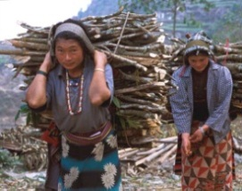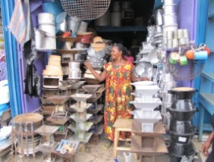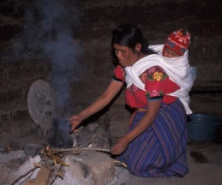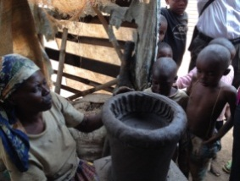

While a thriving global market for clean cooking solutions requires a consumer orientation aimed at meeting their needs in terms of affordability, fuel availability, and cooking style to ensure long-term adoption, it also requires an orientation toward growth and scale that will attract investment beyond the limited donor base.Incorporating best business practices, whether an enterprise is non-profit or for-profit, has increasingly been shown to be both the most consumer-oriented and successful models at attracting additional finance as part of the creation of this thriving global marketplace. For this reason, the Global Alliance is providing its country partners with enterprise capacity building tools at the enterprise and at the market level.

At the enterprise level it is critical to develop a business plan that clearly outlines both the social *and* business models, returns that investors and financiers should expect to achieve, identified risks, and the resources required to successfully implement a business plan. The business plan is your confidential strategy by which you can organize your resources and management team. Additionally, most investors and financiers will expect a business plan that at a minimum follows the outline provided in this toolkit.

While there are a variety of financiers in the marketplace that provide grants, soft-loans, debt and equity instruments that may seek above or below market returns, among many other hybrid instruments, they will all generally evaluate the risks and potential opportunities of financially partnering with an enterprise using a checklist like the following that that will inform them as to the readiness of the enterprise for investment. The investor checklist is furnished here as a means of self-evaluation for enterprises, or as a tool in evaluation for capacity building organizations. The full checklist is not a list of requirements, but it is an indication of what an investor will be looking for when evaluating a business plan or financing opportunity.

Increasingly, impact investors also are demanding a more rigorous approach to impact measurement. As there are traditional metrics to measure financial return, the Global Impact Investment Network (GIIN), has begun attempting the concern of impact investors who either employ different impact investment metrics, or are otherwise unable to calculate and compare their impact investments. Increasingly, it is expected that impact-oriented enterprises and the capacity building organizations that work with them should be familiar with the IRIS taxonomy for impact measurement, in addition to standard financial metrics. In addition, a growing number of the more successful impact-oriented enterprises are receiving a Global Impact Investment Rating or otherwise clearly demonstrating through quantitative and comparable methods their social and financial returns.

At the market level, the more social enterprises that are able to communicate their impact models and returns, the more the social and investment community can understand the risks, rewards and impacts of the clean cooking sector. Alliance partner countries should familiarize themselves with these methods to promote the social and financial impact of the sector through both the literature and successful examples, encourage the adoption of strong financial management and accounting practices, and ensure strong corporate governance as the basic starting point to attract investment into the sector.

Additionally, to increase access to carbon finance to scale adoption of clean cooking solutions, the Alliance is currently developing a comprehensive and interactive carbon finance knowledge sharing platform which will contain information about the different models for accessing carbon finance, guidelines for developing cookstoves carbon projects, as well as templates and standardized tools to assist stakeholders with varying levels of carbon expertise. Many organizations have developed guidelines, tools, and templates to help enable access to carbon finance; rather than duplicating efforts, the portal will leverage and build upon existing materials where possible. The Global Alliance is currently developing the knowledge platform in partnership with stakeholders from the carbon finance and clean cooking communities to ensure it is useful for stakeholders with varying levels of carbon expertise.

**Tools and information included in this step:**

* Investment readiness checklist
* Business plan outline
* Carbon financing portal (currently in development)

# 

**Investment Readiness Checklist:**

This list provides some basic information that most investors will look for during their due diligence process. Keep in mind that each investor has developed a unique due diligence process. A business should be prepared for a lot of questions and site visits. Finally, when an investor approves an investment, it would be helpful to have a consultation on the term sheet and negotiation. Additional online resources are listed at the end of this section.

**Financial Reporting and Standards**

\_\_\_ Audited financial statements for past 3 years or the life of the company

\_\_\_ Ability to report financials quarterly

\_\_\_ Financial model with 3-5 years of projections

\_\_\_ Realistic company valuation (if seeking equity)

\_\_\_ Strong cash flow and cash management

\_\_\_ Burn rate calculation

\_\_\_ Limited debts or debt/ equity ratio  
\_\_\_ Accounting policies are compliant with international standards are in place and followed  
\_\_\_ Previous and current years’ budgets

\_\_\_ Accounts receivable and accounts payable policies that allow for a solid cash flow

\_\_\_ Qualified financial management personnel

**Operational Reporting and Standards**\*Operational risk is broadly defined as risk of loss attributed to people, processes, technology, and degree of vulnerability to external events

\_\_\_ Turnover rate

\_\_\_ Segregation of responsibilities related to accounting and finance (Does one person handle

all of the money, sign the checks and is a singular signatory on the account?)

\_\_\_ Protections against employee fraud and misconduct

\_\_\_ Inventory policies

\_\_\_ Inventory turnover

\_\_\_ A human resources plan and policies

\_\_\_ Details of protection of intellectual property

\_\_\_ Adequate insurance coverage

\_\_\_ Verifiable record of paying taxes, licenses and other operating fees

## Market and Business Planning

\_\_\_ Completed business plan

\_\_\_ Pricing strategy

\_\_\_ Unique selling proposition or market niche

\_\_\_ Key partners are reliable and agreements are firm

\_\_\_ Distribution channels appropriate to market

\_\_\_ Solid sales force or sales strategy

\_\_\_ Strategic planning process is in place with regularly updated growth plan and strategy

**Good Governance**\*You can find tips [here](http://www.governance-works.org/pdfs/tenessential.pdf)

\_\_\_ Constitution, By-laws

\_\_\_ Board of Directors that has the right mix of people, skills and abilities to develop the

organization. A board is almost always a requirement for an equity investment.

\_\_\_ Written set of policies and procedures understood by the board  
\_\_\_ Business plan and model well understood by the board  
\_\_\_ Written code of conduct for the board  
\_\_\_ Regular meetings and board member attendance at meetings  
\_\_\_ Board members regularly receive and read reports including financial reports  
\_\_\_ Board adequately “manages the manager”

\_\_\_ Management with a proven track record and necessary qualifications

\_\_\_ Undisputed share ownership

**Social Impact Reporting and Standards**

\_\_\_ Compelling, socially/ environmentally focused mission statement

\_\_\_ Some measurement of social and/or environmental standards or impact

\_\_\_ System for tracking social and environmental impact

\_\_\_ A social rating from a previous investor or rating agency if possible

**The Pitch and the Deal**

\_\_\_ Company Milestones

\_\_\_ PowerPoint or other sort of “pitch tool”

\_\_\_ Exit strategy

\_\_\_ Non-disclosure agreement

\_\_\_ Growth plan and use of investment

\_\_\_ Acknowledgement of risk and mitigates of risk, especially in operating environment

*\*****Note:*** *Make sure the sell is appropriate to both the company and the investor. Some investors prefer large transactions and require a majority ownership and others prefer smaller transactions with minority ownership. However, the transaction must be big enough to justify the investor’s cost of investing and the risk. For example, many investors will not be interested in investments of less than $100,000 USD.*

**Business Plan Outline for an Emerging Markets Product/**

**Access to Energy Business:**

For our partners working in the private sector, a business plan is usually a necessary step in order to receive an investment. Investors want to know that entrepreneurs have thought out their target market, business model and operations before they begin their complete assessment of an organization. Business plans vary from business type, size and stage of development. The following is a basic outline to follow for a business that provides products to emerging markets but could also be easily adapted to other models. This business plan outline is best utilized when it is customized to a business’ model. For more information on resources to help you with business planning, we have included a list of helpful organizations and online resources. For country-level Alliances, it may be helpful to partner with an entrepreneur support organization that provides specialized instruction and assistance to businesses. For a checklist on investor readiness, see the Business Innovation Facility website [here](http://api.ning.com/files/IAzsD4X16olquAtOftzwTLFL2IVa83fWU1TUGtxNuIrnl7zAb8thlacSfs6Z1n5WfZmWSJB*nlciFzysHrU4X8Py*TcTJ38Z/Checklist_areyouinvestmentreadypdf.pdf).

**Executive Summary**

This section is usually written last, and includes an overview of the business model, the particular market need it addresses, key partners or marketing strategies and overview of investment need and what investment will be used for.

**Business Overview**

Mission

Vision

Current Business Model

Proposed Business Model

Only include this if the business is in the process of changing from current model or plans to change their model to market conditions.

Social Impacts of Model

An impact investor, depending on their investment strategy will require a business to prove a social impact from their products or services. This section should discuss the intended social impacts of the business and if possible, facts and statistics regarding social impact already achieved.

**Product/ Service Descriptions**

Product Overview

Technical Product Specifications with Pictures

Future Products and Services

**Market Analysis**

Market needs/ Gaps- Current “untapped market” section

Business discusses the unmet needs in the market that current businesses do not address. It is helpful to have research in the section to support claims.

Market Segmentation

Business discusses the target market (such as women, young adults) for the product and segments the market based on geography, consumer behaviors, etc. Market segmentation can be complex. Seek additional resources for completing this section.

Industry Information

Business provides any information by industry analysts or organization describing the attractiveness of the industry, market trends and potential for growth.

Competitor Analysis

There are always competitors to the businesses’ products. Even of the product is completely unique; consumers may choose a substitute product or the status quo. This section outlines the competitors and may include the product or service’s advantage over the competition.

**Marketing Plan**

Market Assessment

This section provides an overview of the market assessment and research the business has done. The business should demonstrate that they understand the demands and needs of the target market. Provide a size of the market if possible.

Marketing Strategy

Pricing Strategy

Business demonstrates an effective pricing strategy based on market research and allowing for profitability.

Product Placement

This is synonymous with distribution. How will consumers see the market? Examples include micro-entrepreneurs or retail business placement.

Promotional strategy

Business explains how the product will be branded to distinguish it from others in the market and attract customers. Describe and show how product will be marketed including advertising, social networks, and logos and messaging and important marketing campaigns.

**Operations**

Management team

Write a one paragraph overview of the experience and roles of key team members.

Organization Chart

The organization demonstrates pictorially the reporting structure and roles.

Product Distribution Model

The business explains how their product gets to market, including key relationships. This could be a repeat of the business model above. Include this if the business has important operational characteristics that give it a unique advantage in the market or industry.

Key Partners and Agreements

Business provides an overview of any organization that is essential to business operations or other organizations that assist with marketing efforts. Explain how they interact with the business model and the nature of agreements with the organizations.

Legal Structure, Ownership and Special Operational Permits

The legal structure, license to operate and breakdown of current ownership are presented here. The legal structure is important to an investor, particularly for an equity investment. Note: for companies incorporated as a non-profit, consult local laws before seeking equity investment. In many developed markets, an individual or investor is not able to obtain equity ownership in a non-profit organization.

Country Overview

Business demonstrates that they have an understanding of the operating environment. This is particularly helpful to investors who are not familiar with the market.

**Financial Model**

Risks and Mitigates

This is where a business demonstrates that they have an understanding of the risks to their business and strategies to mitigate the risks to the organization.

Break Even Analysis-

The business shows graphically or explains with financial data when the business will reach the “break-even point,” or being to turn a profit

Exit Strategy

How does the entrepreneur expect a potential investor to exit the company or does the entrepreneur plan to exit the company. Examples include a larger investor buyout, entrepreneur buys out investor, and in very rare cases, an initial public offering (IPO). This is not applicable in most cases to non-profit organizations, depending on the legal system of the country of operation.

Financial Statements

If possible, include up to three years of historical financial statements (balance sheet, income statement, and cash flow) and five years of projections. If seeking an equity investment, it is helpful to have a valuation of the company to begin as a negotiation point with investors.

**Appendices**

Include Project Design Documents (PDD) if company utilizes carbon financing and any relevant contracts with key partners, compelling marketing materials, CVs of key team members, etc.

**Additional Resources:**

**Financial and technical support**

Database of financial and technical support: <http://bit.ly/ib-support-database>

Glossary of business terms: <http://articles.bplans.co.uk/business-terms-glossary>

**Investor Due Diligence and term sheet support**

Raising private capital: <http://www.lighthouse-consulting.com/entrepreneurs_guide.pdf>

Choosing the right funding for your business: [link](http://api.ning.com/files/gJ0sFykN4HlYA4XtSLFh2UyB8i9A-VDDRE1F0sAQOPpLyKzzRN4lfUZaJamkVqaiGnDUDIaWw4jEBwENJZxgR8muOA9fTsYU/Spotlight_AccesstoFinance_Oct12.pdf)

Term Sheet overview: <http://www.feld.com/wp/archives/2008/06/revisiting-the-term-sheet.html>

Exit Strategies: <http://www.exitplanning.com/>

**Business Planning**

Bid Network for entrepreneurs: <http://www.bidnetwork.org/en/resources/entrepreneur-resources>

UK Business Planning Online Guide: [Link](http://articles.bplans.co.uk/writing-a-business-plan/how-to-write-a-business-plan)

Small Business Administration Guides: [Link](http://www.sba.gov/category/navigation-structure/starting-managing-business/starting-business)

Business Innovation Facility: <http://businessinnovationfacility.org/>

**Tracking Social Impacts**

IRIS Overview and taxonomy: <http://iris.thegiin.org/>

Business Innovation Facility Overview on Approaches to tracking social impact: [Link](http://api.ning.com/files/6vphgOtNu35KgEbmRSqbOd6zbOnIUgDiQWGmmHWrg7m66fswQskomr41fQJLWYIsLnYgEJyeFS5nuyVUj6NY7aQCIBU7VVjD/Spotlight_approachscompaniesuse_v2.pdf)

Social Return on Investment Guide: <http://www.thesroinetwork.org/sroi-analysis/the-sroi-guide>

GIIRS Ratings: <http://giirs.org/companies/companies>

# Potential Energy.jpgUganda - Ben West.jpggtz-3-stone-fire-uganda.JPGWoman & child with wood resting Guat(S).jpg

Beyond connecting with stakeholders in your country, providing a means by which stakeholders globally can connect with one another and with the Global Alliance to share lessons learned and best practices is very important. To accomplish this, the Global Alliance has developed an online Partner Community which provides an opportunity for partners to showcase their work through their own online profile and also contains means for networking and engagement. Users can search for organizations in the Partner Directory who are working in particular countries or fields, and partners can edit and update information as they expand their programming or achieve new results. Partners are also displayed on a global map, where users can quickly gain a sense of where Global Alliance partner activities are headquartered, query partners by organization type, and link to more detailed partner profiles.

In addition, users can join topical or regional online Communities of Practice, specifically designed to enable financiers, project implementers, manufacturers, researchers, and others in the sector to interact, share, and collaborate with one another on specific areas of work. The stakeholders working in your country can create a Community of Practice to share information with each other about work taking place locally, as well as work with other partners. In instances where partners and other users have more general questions or information to share, they can now post in the Discussion section. These discussion forums are a critical component of the Global Alliance website, allowing stakeholders to directly add content regarding their work within the sector.

We have included some images of the online tools available to our partners in this section, and encourage you to use the links below to explore the website yourself. Please note: to use the features of the community section of the Global Alliance’s website, you must be a registered member of the community. You can register for free at: <http://community.cleancookstoves.org/registration>

* Community Section of the Global Alliance Website: <http://community.cleancookstoves.org>
* Global Partner Directory: <http://community.cleancookstoves.org/partners/categories>
* Communities of Practice: <http://community.cleancookstoves.org/communities>
* Open Discussion Pages: <http://community.cleancookstoves.org/discussions>

**Community Section of the Alliance Website:**

**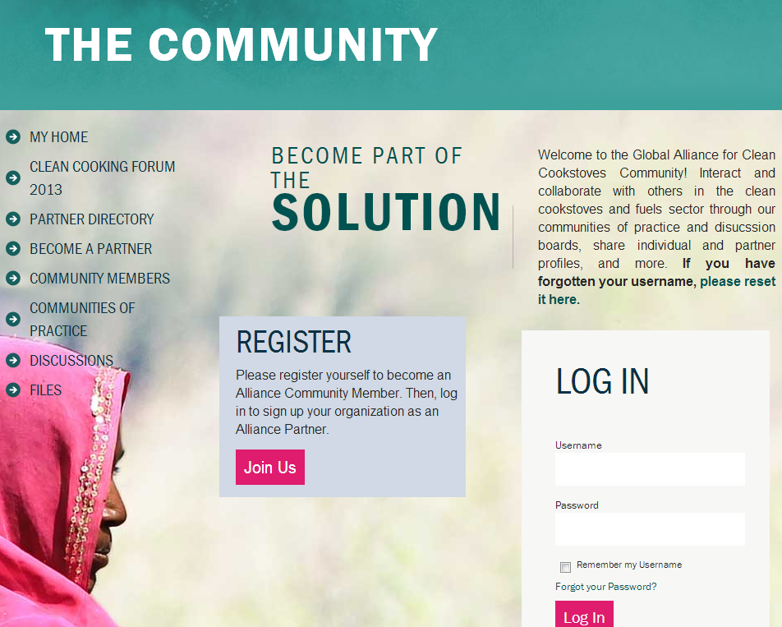**

Visit this page and join the Alliance’s online community at: <http://community.cleancookstoves.org/home>

**Global Partner Directory**:

**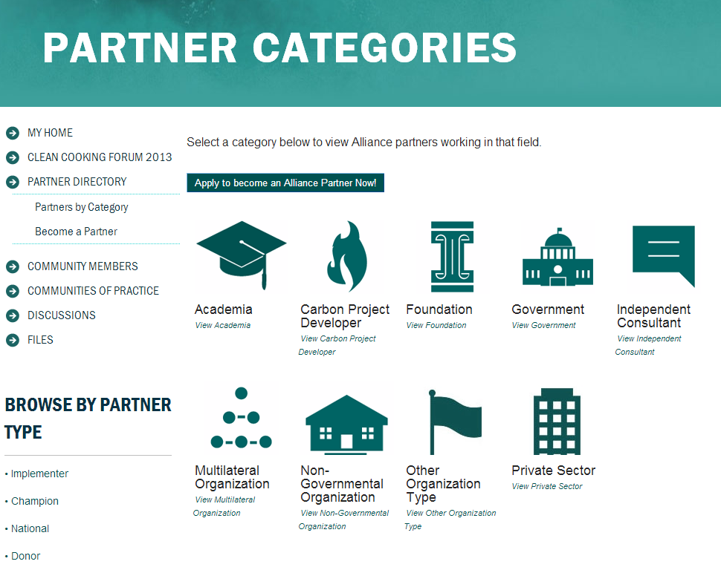**

Visit this page and explore the work being done by the Alliance’s partner organizations at: <http://community.cleancookstoves.org/partners/categories>

**Communities of Practice:**

**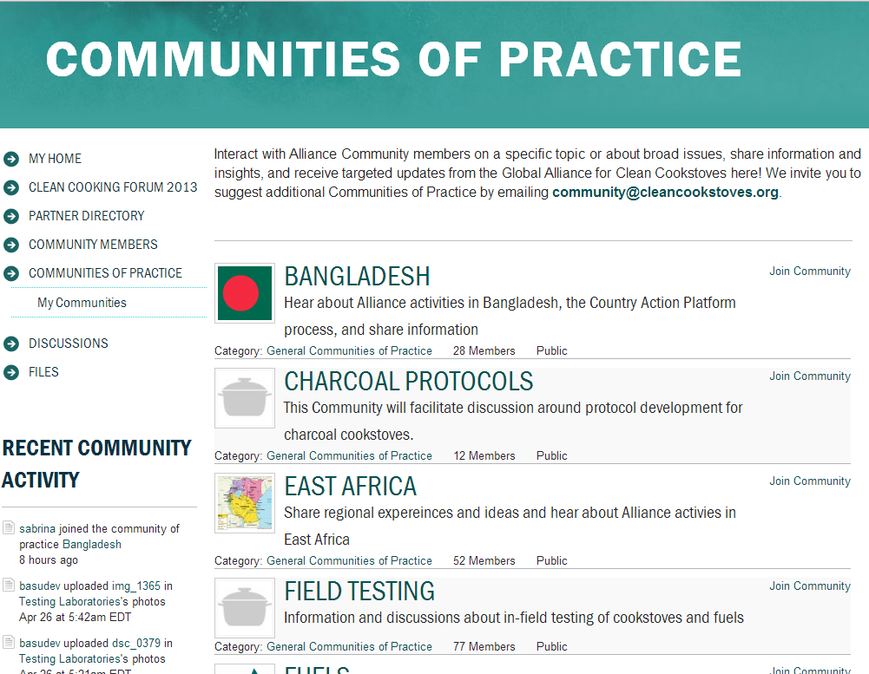**

Visit this page and participate in communities of practice that interest you at: <http://community.cleancookstoves.org/communities>

**Open Discussion Pages:**

**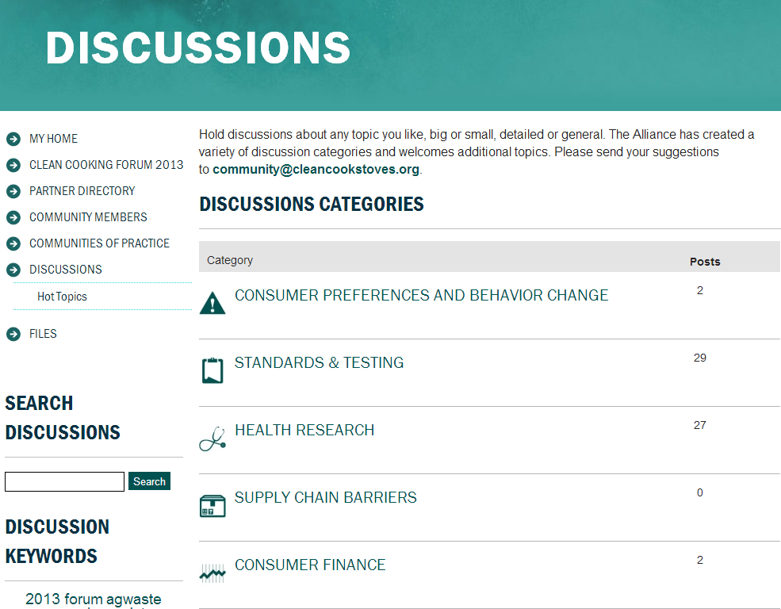**

Visit this page and join the discussion, or start your own discussion topic at: <http://community.cleancookstoves.org/discussions>



**Results Reporting Framework:**

After strategically planning for the work needed to develop the improved cookstoves and fuels markets in your country, it is essential to track and report the progress so that as a group you can evaluate areas of success and areas for improvement. Careful monitoring and evaluation of clean cookstove and fuel adoption programs is critical for observing progress and measuring the impact of the sector’s work. Stakeholders should use clearly understood and transparent indicators that can cost-effectively measure results from the most basic project parameters like cookstove sales, adoption rates, household air pollution, fuel collection time, and fuel and cost savings, to broader objectives regarding saving lives, empowering women, improving livelihoods, and protecting the environment. The Alliance has developed a Results Reporting Framework that can be used by stakeholders to monitor and evaluate their work.

Proper monitoring - the periodic process of gathering data and analyzing or ordering it in a way that the resulting information can be used to determine whether your organization or program is effectively carrying out planned activities -- is imperative to running an effective program. Keeping ongoing records of your organization’s activities more than once per year, ideally quarterly or more frequently, can be used to:

* **Inform management and good decision making to improve program activities;**
* **Provide evidence of the value of program activities to beneficiaries, partners, and donors;**
* **Leverage increased funding and investment opportunities;**
* **Guide national policy decisions; and**
* **Build partnerships.**

The Results Reporting Survey was designed to provide a better understanding of the annual activities of the Global Alliance as reported by its partners, including activities, results, and organizational goals but can also be used for your organization’s own monitoring and evaluation purposes. The questions are organized in sections (manufacturer, distributor, humanitarian, etc.) and are meant to be used by each partner depending on the type of activities they conducted during the year. This document can also be adapted into your own reporting surveys to use as a tool for collecting ongoing information about your organization’s activities and results.

While we are providing this framework for your own use, we would also appreciate if you reported your information to the Global Alliance by emailing your results to [results@cleancookstoves.org](mailto:results@cleancookstoves.org). The information provided in the annual results reporting survey will be used to demonstrate progress towards the adoption of cleaner, more efficient cooking technologies and fuels on a global scale. Providing a collaborative record of the success taking place in the sector through this Results Reporting Survey will benefit all partners and inform the development of global policies, such as standards, as well as help attract financing and investment flows. The information collected annually in our Survey will be used by the Global Alliance to:

* **Recognize partner accomplishments;**
* **Guide the future work of the Global Alliance;**
* **Publicize the collective results of the improved cookstove and fuels sector; and**
* **Determine where additional investments need to be made.**

Only aggregated results will be shared publically from our report; individual partner results will not be reported publicly without explicit permission. All partners are strongly encouraged to submit a results report for their organization.  
  
The 2012 Results Reporting Survey text is [attached](https://unfoundation.box.com/s/6nqfvxochxr7d61jwme0) to this toolkit. If you have any questions on our survey or on how best to adapt it for your purposes, please contact us by emailing: [results@cleancookstoves.org](mailto:results@cleancookstoves.org).

**Other Ideas for Encouraging Monitoring and Evaluation:**

While proper monitoring and evaluation processes are essential for any initiative or business to show their impact and evaluate their own performance, in some cases it is helpful to encourage good monitoring and evaluation processes through other means. Below are a few ways that good monitoring practices can be achieved:

* *Public commitments:* Hold public commitments within the sector, either through the national representative body or through the government, so that stakeholders are publicly committed and accountable for their promised progress. This can result in a yearly commitment ceremony or event to both celebrate accomplished commitments and to make new ones.
* *Sector competitions:* Competitions, with awards given to the organizations or businesses with the most sales, most adopted cookstoves, etc. would prompt many to participate in monitoring and evaluation, as well as making their results public so that they could be considered for such awards.

# Ghana-Radha - Credit Global Alliance for Clean Cookstoves.jpgBedouinCookstoves001.jpgIMG_3184.JPGFamily around fire.jpg

**Alliance Plans to Connect Country Partners:**

While we encourage stakeholders to learn from one another through the community section of the Alliance’s website, we also know that as the Global Alliance that oversees the global markets and sector, we have the perspective from which we can see where lessons learned might be more or less applicable to another setting. The Global Alliance will work in the coming months to connect each partner country to other countries that have similar developmental and socio-economic characteristics, so that they can share information about what types of actions have been successful at growing their own improved cookstoves and fuels markets. Note: reporting to the Global Alliance on progress and challenges will be important in helping us evaluate where lessons learned could be the most applicable.

The Global Alliance will spend time over the next year interacting with each of its partner countries to understand where in the market development process they are, where they are thriving, where they face challenges, and where they need assistance. We will also look at other factors such as location, fuel use and availability, technologies available in country, and consumer segmentation among others to determine what markets could benefit from each other’s learnings. After analysis of this information, the Global Alliance will connect you to another partner country so that you can work together and learn from one another’s experiences. Note: this will likely take place through the Global Alliance affiliate organizations, so we encourage your stakeholder group to become an official affiliate member of the Global Alliance to better facilitate this progress.

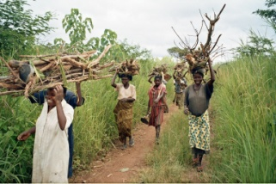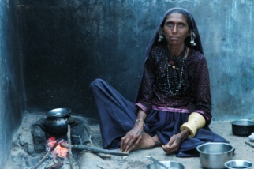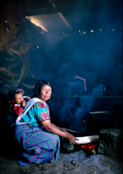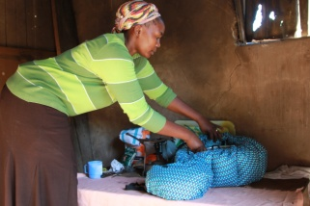

**The Importance of Reevaluating Interventions for Continued Improvement:**

In a growing and evolving market and field such as improved cookstoves and fuels, it is essential that the sector is able to keep up with new innovation, new information, and new insights. To ensure that all consumers are able to access the latest technological advances ensuring the cleanest, safest cookstoves for each country’s population, as well as to make sure that business practices and policy decisions are using the most up to date information, the sector must repeat the steps outlined above every three to five years. Being able to use the most relevant information will enable the sector to progress faster and more efficiently, ensuring that more people are able to adopt improved cookstoves and fuels, that more businesses are able to thrive, and that the health, environmental, and gender impacts of traditional cookstove and fuel use no longer impact people globally.

As part of our commitment to helping each of our partner country’s improved cookstove and fuel market thrive, the Alliance will commit to updating you with new information and new tools, many of which are outlined in this toolkit, when the new information is available or biannually. If through your own experience or through your use of this document you find information that could be helpful to the sector at large, please contact the Alliance at [knowledge@cleancookstoves.org](mailto:knowledge@cleancookstoves.org) so that we can make this information available to the broader sector.

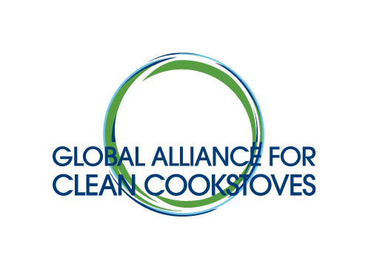

[www.cleancookstoves.org](http://www.cleancookstoves.org/)  
[info@cleancookstoves.org](mailto:info@cleancookstoves.org)

**+1 202 650 5345**