SE4ALL Consultation Workshop: Monitoring the Status of Asia-Pacific
14 June 2015 | Discovery Suites, Ortigas Center, Pasig City, Philippines
INFORMATION NOTE

Welcome to the SE4All Consultation Workshop: Monitoring the Status of Asia-Pacific. The Consultation Workshop will take place on 14 June 2015 at Columbus Room, 42nd Floor, Discovery Suites, 25 ADB Avenues, Ortigas Center, Pasig City, Philippines (Kindly take the elevator to the 41st Floor and take the staircase leading to the 42nd Floor.)

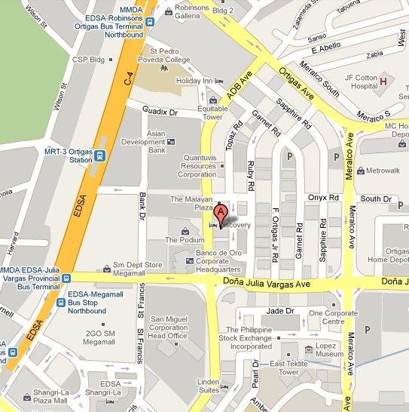

Arrival in Manila

Upon arrival at the Ninoy Aquino International Airport Terminal 1 & 3 (NAIA), you may proceed to the International Organizations Desk located at the airport lobby where an ADB representative will direct you to the taxi queue (at the Arrival Area) for your transfer to the hotel. If arriving at the Centennial Airport (Terminal 2), you may proceed directly to the taxi queue outside the arrival area

For your convenience, you may avail of accredited fixed rate or metered taxi cabs. Accredited transfer services on a pre-paid coupon basis currently charge a rate of Philippine Peso (PhP) 610 or about USD14.00 (PhP44.60: US$1.00) from airport to Ortigas Center, where ADB and Discovery Suites are located. Accredited NAIA airport metered taxis (an alternative to prepaid coupon taxis) generally fetch lower rates at PhP400 to PhP500 (one way).

Workshop Program

Registration will start at 8:30am.
Workshop Program is attached.
Groupings for the case studies and break-out session will be provided on Sunday.

Hospitality Arrangements

Hosted lunch as well as morning and afternoon snacks will be served during the workshop.

Departure from Manila

On your departure from Manila, you are advised to confirm ahead of time with the hotel desk regarding your transfer arrangement to the airport or you can take a regular taxi to go to the airport. Due to occasional heavy traffic between Ortigas Center and the airport, it is advisable to leave for the airport at least three (3) hours before your flight departure. Please prepare PhP550 or its dollar equivalent (about US$13) for payment of the international terminal fee.

Philippine Country Information

For more information about local weather, currency, transport, business hours, and others, please visit http://www.tourism.gov.ph/Pages/default.aspx.

Workshop Secretariat
Should you have additional questions about the Workshop, please contact:

Ms. Marianne Joy Vital
E-mail: mvital.consultant@adb.org

Ms. Jhoanna Quimson
Email: jquimson.consultant@adb.org

Ms. Ana Maria Tolentino
E-mail: atolentino.consultant@adb.org

OTHER ENERGY FOR ALL EVENTS DURING ASIA CLEAN ENERGY FORUM 2015 at ADB Headquarters:

*For more information please visit www.asiacleanenergyforum.org

Monday, 15 June:

9:00AM – 12:30PM – Deep Dive Workshop on Hybrid Renewable Minigrids: Their potential for expanding energy access and reducing diesel dependency

2:00PM – 5:30PM – Deep Dive Workshop on Unlocking Energy Access Impact, Investment, Scale and Sustainability through Gender-Sensitive Approaches

Tuesday, 16 June:

8:30AM – 5:30PM – SE4All Investor Forum

Wednesday, 17 June:

11:00AM – 12:30PM – Energy Access Track session on New and Innovative Business Models to Expand Access

2:00PM – 3:30PM - Energy Access Track session on Mini-Grids to Expand Access

Thursday, 18 June:

9:00AM – 10:30 – Energy Access Track Session on Improved Cooking Solutions

